JAYAPRIYA VIDYALAYA
SENIOR SECONDARY SCHOOL
[Affiliated to CBSE, New Delhi ,Affiliation Code-1930685]

ALL INDIA SENIOR SCHOOL CERTIFICATE EXAMINATION [AISSCE] – 2022-23



COMPUTER SCIENCE (083) – PROJECT REPORT ON
JOB ALERT
Submitted By
TYPE OF THE PROJECT :GROUP PROJECT
SL.NO. | ROLL NO. | NAME OF THE STUDENT | CLASS &SECTION
1 |  | Kathirvel.S | XII-A2
2 |  | Abishaken.S | XII-A2
3 |  | Pavinthan.V | XII-A2

Under the Guidance of
Mr.S.BASKARAN M.Sc., B.Ed., PGDCA
Department of Computer Science

Teacher In-Charge Principal
D E C L A R AT I O N

I declare that the work presented in this project titled “JOB ALERT” submitted to Mr.S.Baskaran, PGT-Computer Science , JayapriyaVidyalaya Sr. Sec. School , Virudhachalam for the award of the All India Senior School Certificate Examination [AISSCE] – 2022-23.
I have not plagiarized or submitted the same work for the award of any other examination.

January, 2023

Place : JayapriyaVidyalayaSr.Sec.School,
Virudhachalam

KATHIRVEL.S
ABISHAKEN.S
PAVINTHAN.V
CLASS XII-A2

CERTIFICATE

This is to certify that KATHIRVEL.S , ABISHAKEN.S , PAVINTHAN.V of Class XII “A2” has prepared the record on the Project entitled

“JOB ALERT”

The report is the result of their efforts & endeavours.
The report is found worthy of acceptance as final project report for the subject Computer Science (083) of Class XII- A2
They had prepared the report under my guidance.

Mr.S.BASKARAN M.Sc.,B.Ed.,PGDCA
Department of Computer Science
JayapriyaVidyalaya Sr. Sec. School
Virudhachalam

JAYAPRIYA VIDYALAYA
SENIOR SECONDARY SCHOOL
[Affiliated to CBSE, New Delhi ,Affiliation Code-1930685]
ALL INDIA SENIOR SCHOOL CERTIFICATE EXAMINATION [AISSCE] – 2022-23


CERTIFICATE
The project report entitled
" JOB ALERT"
Submitted by

Kathirvel.S , Abishaken.S , Pavinthan.V of Class XII “A2” for the
All India Senior School Certificate Examination [AISSCE] –2022-23 of Computer Science at JayapriyaVidyalaya Senior Secondary School, Virudhachalam has been Examined.

Signature of Internal Examiner Signature of External Examiner

ACKNOWLEDGEMENT
I would like to register my sense of gratitude to our Principal
DR.Prasanna for his immense encouragement that made this project successful.

I would like to express a deep sense of thanks to my project guide Mr.S.Baskaran PGT in Computer Science for guiding me immensely through the course of the project. He always evinced keen interest in my work.

His constructive advice & constant motivation have been responsible for the successful completion of this project.

I wish to thank my parents for their motivation &support.
and my special thank to my classmates for their timely help & support for the completion of this project.

We owe our sincere gratitude towards JayapriyaVidyalaya
Senior Secondary School,Virudhachalam.

Our heartfelt thanks to CBSE for given this opportunity to do this project.

Last but not the least, I would like to thank all those who had helped directly or indirectly towards the completion of this project.

Kathirvel.S
Abishaken.S
Pavinthan.V
CLASS-XII-A2

CONTENT

SL.NO. | PARTICULARS | PAGE NO.
1. | Introduction about the project | 1
2. | System, Software and Hardware requirements | 2
3. | Introduction about Python | 3
4. | Introduction about MySQL | 4-7
5. | System Development Life Cycle (SDLC) | 7
6. | Phases of system development life cycle | 8-15
7. | Project Design | 16
8. | Python code | 17-78
9. | Output screenshots | 79-82
10. | Database screenshots | 83
11. | Advantages of project | 84
12. | Further development areas | 84
13. | Bibliography | 85

Introduction about the project :JOB ALERT.
- This project consists of two parts which are searching for employee and searching for employment.
- This project will be helpful to the job seekers .
FOR EMPLOYER:
- This project will useful for some start-up company who searching for employees.
- The employer can see the profile of employee.
- This helps employer to search a good employee in short time.
FOR JOB SEEKERS:
- This project will be helpful to the job seekers .
- The employee can visit the job offers from employer and if they interest with that offer they can send their resume to the employer.
- By this project many people get job.
- The job seekers can see various job opportunities in this platform and they can apply based on their skill sets / Qualification.

1

System Requirements of the Project

Recommended System Requirements
Processors: Intel® Core™ i3 processor 4300M at 2.60 GHz.
Disk space: 2 to 4 GB.
Operating systems: Windows® 10, / MAC OS / UBUNTU.
Python Versions: 3.X.X or Higher.
MySQL- 8.0.X

Minimum System Requirements
Processors: Intel Atom® processor or Intel® Core™ i3 processor.
Disk space: 1 GB.
Operating systems: Windows 7 or later / MAC OS / UBUNTU.
Python Versions: 3.8.X.
MySQL- 8.0.X

Pre requisites before installing MySQL Connector Python
You need root or administrator privileges to perform the installation process.
Python must be installed on your machine.

Note: – MySQL Connector Python requires python to be in the system’s PATH. Installation fails if it doesn’t find Python.

On Windows, If Python doesn’t exist in the system’s PATH, please manually add the directory containing python.exe yourself.
2
Introduction about Python

Python is a high level, interpreted and general purpose dynamic programming language that focuses on code readability. It has fewer steps when compared to Java and C. It was founded in 1991 by developer Guido Van Rossum. It is used in many organizations as it supports multiple programming paradigms. It also performs automatic memory management.
Advantages :
1) Presence of third-party modules
2) Extensive support libraries(NumPy for numerical calculations, Pandas for data analytics etc.)
3) Open source and community development
4) Easy to learn
5) User-friendly data structures
6) High-level language
7) Dynamically typed language(No need to mention data type based on value assigned, it takes data type)
8) Object-oriented language
9) Portable and Interactive
10) Portable across Operating systems

Applications :
1) GUI based desktop applications(Games, Scientific Applications)
2) Web frameworks and applications
3) Enterprise and Business applications
4) Operating Systems
5) Language Development
6) Prototyping
Introduction about MySQL
MySQL is a relational database management system (RDBMS) based on the SQL (Structured Query Language) queries. It is one of the most popular languages for accessing and managing the records in the table. MySQL is open-source and free software under the GNU license. Oracle Company supports it.
The following are the most important features of MySQL:
Relational Database Management System (RDBMS)
MySQL is a relational database management system. This database language is based on the SQL queries to access and manage the records of the table.
Easy to use
MySQL is easy to use. We have to get only the basic knowledge of SQL. We can build and interact with MySQL by using only a few simple SQL statements.
It is secure
MySQL consists of a solid data security layer that protects sensitive data from intruders. Also, passwords are encrypted in MySQL.
Client/ Server Architecture
MySQL follows the working of a client/server architecture. There is a database server (MySQL) and arbitrarily many clients (application programs), which communicate with the server; that is, they can query data, save changes, etc.
Free to download
MySQL is free to use so that we can download it from MySQL official website without any cost.
It is scalable
MySQL supports multi-threading that makes it easily scalable. It can handle almost any amount of data, up to as much as 50 million rows or more. The default file size limit is about 4 GB. However, we can increase this number to a theoretical limit of 8 TB of data.
Speed
MySQL is considered one of the very fast database languages, backed by a large number of the benchmark test.
High Flexibility
MySQL supports a large number of embedded applications, which makes MySQL very flexible.
Compatible on many operating systems
MySQL is compatible to run on many operating systems, like Novell NetWare, Windows* Linux*, many varieties of UNIX* (such as Sun* Solaris*, AIX, and DEC* UNIX), OS/2, FreeBSD*, and others. MySQL also provides a facility that the clients can run on the same computer as the server or on another computer (communication via a local network or the Internet).
Allows roll-back
MySQL allows transactions to be rolled back, commit, and crash recovery.
Memory efficiency
Its efficiency is high because it has a very low memory leakage problem.

High Performance
MySQL is faster, more reliable, and cheaper because of its unique storage engine architecture. It provides very high-performance results in comparison to other databases without losing an essential functionality of the software. It has fast loading utilities because of the different cache memory.
High Productivity
MySQL uses Triggers, Stored procedures, and views that allow the developer to give higher productivity.
Platform Independent
It can download, install, and execute on most of the available operating systems.
Partitioning
This feature improves the performance and provides fast management of the large database.
GUI Support
MySQL provides a unified visual database graphical user interface tool named "MySQL Workbench" to work with database architects, developers, and Database Administrators. MySQL Workbench provides SQL development, data modeling, data migration, and comprehensive administration tools for server configuration, user administration, backup, and many more. MySQL has a fully GUI supports from MySQL Server version 5.6 and higher.

Dual Password Support
MySQL version 8.0 provides support for dual passwords: one is the current password, and another is a secondary password, which allows us to transition to the new password.
System Development Life Cycle (SDLC)

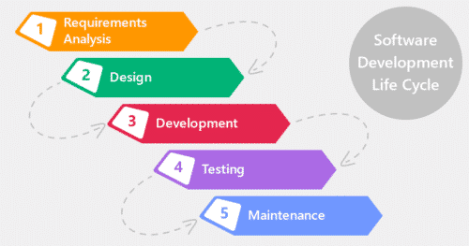

The systems development life cycle is a project management technique that
divides complex projects into smaller, more easily managed segments or phases.
Segmenting projects allows managers to verify the successful completion of project phases before allocating resources to subsequent phases.

Software development projects typically include initiation, planning, design,
development, testing, implementation, and maintenance phases. However, the
phases may be divided differently depending on the organization involved.
For example, initial project activities might be designated as request,
requirements-definition, and planning phases, or initiation, concept-development and planning phases. End users of the system under development should be involved in reviewing the output of each phase to ensure the system is being built to deliver the needed functionality.

PHASES OF SYSTEM DEVELOPMENT LIFE CYCLE

INITIATION PHASE
The Initiation Phase begins when a business sponsor identifies a need or an
opportunity.
The purpose of the Initiation Phase is to:
● Identify and validate an opportunity to improve business accomplishments of
the organization or a deficiency related to a business need.
● Identify significant assumptions and constraints on solutions to that need.
● Recommend the exploration of alternative concepts and methods to satisfy
the need including questioning the need for technology, i.e., will a change in
the business process offer a solution?
● Assure executive business and executive technical sponsorship. The Sponsor
designates a Project Manager and the business need is documented in a
Concept Proposal. The Concept Proposal includes information about the
business process and the relationship to the Agency/Organization.
● Infrastructure and the Strategic Plan. A successful Concept Proposal results
in a Project Management Charter which outlines the authority of the project
manager to begin the project.
Careful oversight is required to ensure projects support strategic business
objectives and resources are effectively implemented into an organization's
enterprise architecture. The initiation phase begins when an opportunity to add,
improve, or correct a system is identified and formally requested through the
presentation of a business case. The business case should, at a minimum, describe a proposal’s purpose, identify expected benefits, and explain how the proposed
system supports one of the organization’s business strategies. The business case should also identify alternative solutions and detail as many informational, functional and network requirements as possible.
SYSTEM CONCEPT DEVELOPMENT PHASE
The System Concept Development Phase begins after a business need or
opportunity is validated by the Agency/Organization Program Leadership and the Agency/Organization CIO.
The purpose of the System Concept Development Phase is to:
● Determine the feasibility and appropriateness of the alternatives.
● Identify system interfaces.
● Identify basic functional and data requirements to satisfy the business need.
● Establish system boundaries; identify goals, objectives, critical success
factors, and performance measures.
● Evaluate costs and benefits of alternative approaches to satisfy the basic
functional requirements
● Assess project risks
● Identify and initiate risk mitigation actions, andDevelop high-level technical
architecture, process models, data models, and a concept of operations. This
phase explores potential technical solutions within the context of the business
need.
● It may include several trade-off decisions such as the decision to use COTS
software products as opposed to developing custom software or reusing
software components, or the decision to use an incremental delivery versus a
complete, onetime deployment.
● Construction of executable prototypes is encouraged to evaluate technology
to support the business process. The System Boundary Document serves as
an important reference document to support the Information Technology
Project Request (ITPR) process.
● The ITPR must be approved by the State CIO before the project can move
forward.

PICTORIAL REPRESENTATION OF SDLC:

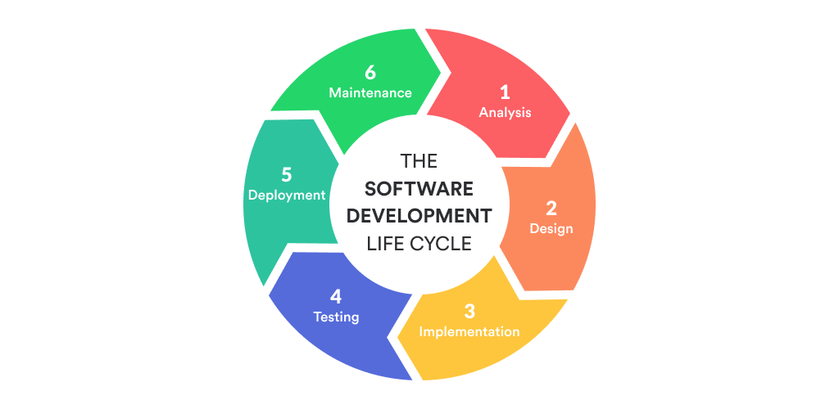

PLANNING PHASE

The planning phase is the most critical step in completing development,
acquisition, and maintenance projects. Careful planning, particularly in the early
stages of a project, is necessary to coordinate activities and manage project risks
effectively. The depth and formality of project plans should be commensurate with the characteristics and risks of a given project. Project plans refine the information gathered during the initiation phase by further identifying the specific activities and resources required to complete a project.
A critical part of a project manager’s job is to coordinate discussions between
user, audit, security, design, development, and network personnel to identify and document as many functional, security, and network requirements as possible. During this phase, a plan is developed that documents the approach to be used and includes a discussion of methods, tools, tasks, resources, project schedules, and user input. Personnel assignments, costs, project schedule, and target dates are established.
A Project Management Plan is created with components related to acquisition
planning, configuration management planning, quality assurance planning, concept of operations, system security, verification and validation, and systems engineering management planning.

REQUIREMENTS ANALYSIS PHASE

This phase formally defines the detailed functional user requirements using
high-level requirements identified in the Initiation, System Concept, and Planning phases. It also delineates the requirements in terms of data, system performance, security, and maintainability requirements for the system. The requirements are defined in this phase to a level of detail sufficient for systems design to proceed. They need to be measurable, testable, and relate to the business need or opportunity identified in the Initiation Phase. The requirements that will be used to determine acceptance of the system are captured in the Test and Evaluation Master Plan.

The purposes of this phase are to:
● Further define and refine the functional and data requirements and document
them in the Requirements Document,
● Complete business process reengineering of the functions to be supported
(i.e., verify what information drives the business process, what information is
generated, who generates it, where does the information go, and who
processes it),
● Develop detailed data and process models (system inputs, outputs, and the
process.
● Develop the test and evaluation requirements that will be used to determine
acceptable system performance .

DESIGN PHASE

The design phase involves converting the informational, functional, and
network requirements identified during the initiation and planning phases into unified design specifications that developers use to script programs during the development phase. Program designs are constructed in various ways. Using a top-down approach, designers first identify and link major program components and interfaces, then expand design layouts as they identify and link smaller subsystems and connections. Using a bottom-up approach, designers first identify and link minor program components and interfaces, then expand design layouts as they identify and link larger systems and connections. Contemporary design techniques often use prototyping tools that build mock-up designs of items such as application screens, database layouts, and system architectures. End users, designers, developers, database managers, and network administrators should review and refine the
prototyped designs in an iterative process until they agree on an acceptable design. Audit, security, and quality assurance personnel should be involved in the review and approval process. During this phase, the system is designed to satisfy the functional requirements identified in the previous phase. Since problems in the design phase could be very expensive to solve in the later stage of the software development, a variety of elements are considered in the design to mitigate risk.

These include:
● Identifying potential risks and defining mitigating design features.
● Performing a security risk assessment.
● Developing a conversion plan to migrate current data to the new system.
● Determining the operating environment.
● Defining major subsystems and their inputs and outputs.
● Allocating processes to resources.
● Preparing detailed logic specifications for each software module. The result is
a draft System Design Document which captures the preliminary design for
the system.
● Everything requiring user input or approval is documented and reviewed by
the user. Once these documents have been approved by the Agency CIO and
Business Sponsor, the final System Design Document is created to serve as
the Critical/Detailed Design for the system.
● This document receives a rigorous review by Agency technical and functional
representatives to ensure that it satisfies the business requirements.
Concurrent with the development of the system design, the Agency Project
Manager begins development of the Implementation Plan, Operations and
Maintenance Manual, and the Training Plan.

DEVELOPMENT PHASE
The development phase involves converting design specifications into
executable programs. Effective development standards include requirements that programmers and other project participants discuss design specifications before programming begins. The procedures help ensure programmers clearly
understand program designs and functional requirements. Programmers use
various techniques to develop computer programs. The large transaction oriented programs associated with financial institutions have traditionally been developed using procedural programming techniques. Procedural programming involves the line-by-line scripting of logical instructions that are combined to form a program. Effective completion of the previous stages is a key factor in the success of the Development phase. The Development phase consists of:
● Translating the detailed requirements and design into system components.
● Testing individual elements (units) for usability.
● Preparing for integration and testing of the IT system.
INTEGRATION AND TEST PHASE
● Subsystem integration, system, security, and user acceptance testing is
conducted during the integration and test phase. The user, with those
responsible for quality assurance, validates that the functional requirements,
as defined in the functional requirements document, are satisfied by the
developed or modified system. OIT Security staff assess the system security
and issue a security certification and accreditation prior to
installation/implementation.

Multiple levels of testing are performed, including :
● Testing at the development facility by the contractor and possibly supported
by end users
● Testing as a deployed system with end users working together with contract
personnel
● Operational testing by the end user alone performing all functions.
Requirements are traced throughout testing, a final Independent Verification &
Validation evaluation is performed and all documentation is reviewedand
accepted prior to acceptance of the system.

IMPLEMENTATION PHASE

This phase is initiated after the system has been tested and accepted by the
user. In this phase, the system is installed to support the intended business
functions. System performance is compared to performance objectives established during the planning phase. Implementation includes user notification, user training, installation of hardware, installation of software onto production computers, and integration of the system into daily work processes. This phase continues until the system is operating in production in accordance with the defined user requirements.

OPERATIONS AND MAINTENANCE PHASE
The system operation is ongoing. The system is monitored for continued
performance in accordance with user requirements and needed system
modifications are incorporated. Operations continue as long as the system can be effectively adapted to respond to the organization’s needs. When modifications or changes are identified, the system may re enter the planning phase.
The purpose of this phase is to:
● Operate, maintain, and enhance the system.
● Certify that the system can process sensitive information.
● Conduct periodic assessments of the system to ensure the functional
requirements continue to be satisfied.
● Determine when the system needs to be modernized, replaced, or retired.

PROJECT DESIGN
SIGN-UP
WINDOW
SIGNIN
WINDOW

EMPLOYER
PAGE
EMPLOYEE
PAGE

JOB SEEKERS PROFILES
VACCANT
LIST
JOB OPPORTUNITIES
RESUME MAKING

DATABASE

PYTHON CODE
Frontend:

import tkinter as tk
from tkinter import *
from tkinter import messagebox
import backend

root =tk.Tk()
root.geometry('1000x600')
root.title('JOB-ALERT')
root.resizable(False,False)
#=======================================================Images=========================================================================
img1 = PhotoImage(file='login.png')
img2 = PhotoImage(file='uiux-design.png')
img3=PhotoImage(file='ui (2).png')
img4=PhotoImage(file='verification-removebg-preview.png')
roundentry=PhotoImage(file='verification-removebg-preview.png')
img5=PhotoImage(file='BeFunky-design.png')
img6=PhotoImage(file='NEW ONE.png')
background=PhotoImage(file='EMPLOYEE001.png')
img9=PhotoImage(file='employer.png')
img10=PhotoImage(file='email_verifier.png')
img7=PhotoImage(file='password profile png.png')
img8=PhotoImage(file='usernameid show.png')
img11=PhotoImage(file='mail get.png')
swn=PhotoImage(file='something went.png')
img12=PhotoImage(file='forgot_password_page1.png')
#========================================================x===========================================================================
def stw():
fp=Label(root,bg='white',image=swn)
fp.place(x=0,y=0)
def sign_inpage():
window=Label(root,bg='white',height=600,width=1000).place(x=0,y=0)
Label(window,image=img1,bg='white').place(x=40,y=110)
def sign_in():
username=user.get()
password=user1.get()
if username in ['Username',''] or password in ['Password','']:
Frame(frame,width=390,height=2,bg='red').place(x=30,y=130)
Frame(frame,width=390,height=2,bg='red').place(x=30,y=210)
messagebox.showerror(f'error','fill it properly')

else:
res=backend.sign_in_db(username,password)
if res=='employer':
root.destroy()
employee_120(username)
elif res=='employee':
root.destroy()
employer_120(username)
elif res=='invalid password':
Frame(frame,width=390,height=2,bg='red').place(x=30,y=210)
messagebox.showerror(f'WRONG PASSWORD','ERROR')
elif res== 'user name not found':
Frame(frame,width=390,height=2,bg='red').place(x=30,y=130)
Frame(frame,width=390,height=2,bg='red').place(x=30,y=210)
messagebox.showerror(f'user name','user name not found')

frame=Frame(window,width=450,height=500,bg='white')
frame.place(x=480,y=70)

heading=Label(frame,text='Sign in',fg='#57a1f8',bg='white',font=('Microsoft YaHei UI light',30,'bold'))
heading.place(x=150,y=5)
#------------------------------------------------------------------------------------------------------------------------------
def on_entry(e):
name1=user.get()
if name1=='Username':
user.delete(0,END)
def on_leave(e):
name=user.get()
if name=='':
user.insert(0,'Username')
else:
Frame(frame,width=390,height=2,bg='black').place(x=30,y=130)

user = Entry(frame,width=35,fg='black',border=0,bg='white',font=('Microsoft YaHei UI light',15))
user.place(x=30,y=100)
user.insert(0,'Username')
user.bind('<FocusIn>',on_entry)
user.bind('<FocusOut>',on_leave)
Frame(frame,width=390,height=2,bg='black').place(x=30,y=130)

#----------------------------------------------------------------------------------------------
def on_entry(e):
name1=user1.get()
#Frame(frame,width=390,height=3,bg='red').place(x=30,y=130)
if name1=='Password':
user1.delete(0,END)
def on_leave(e):
name=user1.get()
if name=='':
user1.insert(0,'Password')
else:
Frame(frame,width=390,height=2,bg='black').place(x=30,y=210)
user1 = Entry(frame,width=35,fg='black',border=0,bg='white',font=('Microsoft YaHei UI light',15))
user1.place(x=30,y=180)
user1.insert(0,'Password')
user1.bind('<FocusIn>', on_entry)
user1.bind('<FocusOut>', on_leave)
Frame(frame,width=390,height=2,bg='black').place(x=30,y=210)

####################################################################
Button(frame,width=49,pady=10,text='Sign in',bg='#57a1f8',fg='white',border=0,command=sign_in).place(x=40,y=259)
label0=Label(frame,text="Don't have an account?",fg='black',bg='white',font=('Microsoft YaHei UI light',10,'bold'))
label0.place(x=75,y=320)
Button(frame,text='sign up',border=0,bg='white',fg='#57a1f8',font=('Microsoft YaHei UI light',8,'bold'),cursor='hand2',command=sign_up).place(x=250,y=321)
Button(frame,text='Forgot Password?',border=0,bg='white',fg='#57a1f8',font=('Microsoft YaHei UI light',10,'bold'),cursor='hand2',command=forgatpass).place(x=130,y=345)
'''--------------------------------------------------------------------------------------------------------------'''
def change_pass(po):
def next1_od():
if len(np.get())>=8:
if np.get()==cp.get():
backend.update_pass(po,np.get())
sign_inpage()
else:
Frame(f1,bg='red',width=360,height=2).place(x=35,y=305)
else:
Frame(f1,bg='red',width=360,height=2).place(x=35,y=185)
w7=Label(root,height=600,width=1000,bg='white')
w7.place(x=0,y=0)
Label(w7,image=img7,bg='white').place(x=50,y=50)
f1=Frame(w7,bg='white',height=530,width=430)
f1.place(x=530,y=40)
Label(f1,bg='white',fg='#57a1f8',font=('Microsoft YaHei UI light',30,'bold'),text='New password').place(x=50,y=30)
np=Entry(f1,bg='white',fg='black',width=21,font=('Segoe UI',23),border=0)
np.place(x=35,y=140)
Frame(f1,bg='black',width=360,height=2).place(x=35,y=185)
cp=Entry(f1,bg='white',fg='black',width=21,font=('Segoe UI',23),border=0)
cp.place(x=35,y=260)
Frame(f1,bg='black',width=360,height=2).place(x=35,y=305)
Button(f1,bg='#57a1f8',fg='white',font=('Segoe UI',15),border=0,text='Next',width=20,command=next1_od).place(x=100,y=380)
def on_entry1(e):
if np.get() == 'Password':
np.delete(0,'end')
def on_leave1(e):
if np.get()=='':
np.insert(0,'Password')

def on_entry(e):
if cp.get() == 'Confirm Password':
cp.delete(0,'end')
def on_leave(e):
if cp.get()=='':
cp.insert(0,'Confirm Password')
np.insert(0,'Password')
cp.insert(0,'Confirm Password')
cp.bind('<FocusIn>',on_entry)
cp.bind('<FocusOut>',on_leave)
np.bind('<FocusIn>',on_entry1)
np.bind('<FocusOut>',on_leave1)
def forgatpass():
k=[]
def changepass():
if int(user1.get()) in k:
change_pass(user.get())
else:
Frame(w9,height=2,width=340,bg='red').place(x=590,y=322)
def backgo():
sign_inpage()
def on_entry1(e):
a=user.get()
if a=='USER NAME':
user.delete(0,'end')
def on_leave1(e):
a=user.get()
if a=='':
user.insert(0,'USER NAME')
else:
m=backend.forgat_pass(a)
if m:
p='Your no'+m[0]+'*****'+m[8]+m[9]
o=Label(w9,text=p,bg='white',fg='black',font=('Microsoft YaHei UI light',18))
o.place(x=590,y=240)
k.append(backend.send_now(m))
w9=Label(root,image=img12,height=600,width=1000,bg='black')
w9.place(x=0,y=0)
user=Entry(w9,width=16,fg='black',border=0,bg='white',font=('Microsoft YaHei UI light',28))
user.place(x=590,y=170)
Frame(w9,height=2,width=340,bg='black').place(x=590,y=214)
user1=Entry(w9,width=16,fg='black',border=0,bg='white',font=('Microsoft YaHei UI light',28))
user1.place(x=590,y=280)
Frame(w9,height=2,width=340,bg='black').place(x=590,y=322)
user.insert(0,'USER NAME')
Button(w9,text='Next',bg='#57a1f8',fg='white',border=0,font=('Microsoft YaHei UI light',21,'bold'),width=8,activebackground='white',command=changepass).place(x=790,y=370)
Button(w9,text='Back',bg='#57a1f8',fg='white',border=0,font=('Microsoft YaHei UI light',21,'bold'),width=8,activebackground='white',command=backgo).place(x=590,y=370)

user.bind('<FocusIn>',on_entry1)
user.bind('<FocusOut>',on_leave1)

'''-----------------------------------------------------------------------------------------------------------------'''
def sign_up():
window1=Label(root,bg='white',height=600,width=1000).place(x=0,y=0)
Label(window1,image=img2,bg='white').place(x=0,y=20)
frame=Frame(window1,width=400,height=520,bg='white')
frame.place(x=580,y=50)
heading=Label(frame,text='Sign up',fg='#57a1f8',bg='white',font=('Microsoft YaHei UI light',30,'bold'))
heading.place(x=125,y=5)
#------------------------------------------------------------------------------------------------
def on_entry1(e):
name1=user.get()
if name1=='Your name':
user.delete(0,'end')
def on_leave1(e):
name=user.get()
if name=='':
user.insert(0,'Your name')
return False
elif name.isalpha():
Frame(frame,width=341,height=2,bg='black').place(x=30,y=140)
return True
else:
Frame(frame,width=341,height=2,bg='red').place(x=30,y=140)
return False

user = Entry(frame,width=31,fg='black',border=0,bg='white',font=('Microsoft YaHei UI light',15))
user.place(x=30,y=110)
user.insert(0,'Your name')
user.bind('<FocusIn>',on_entry1)
user.bind('<FocusOut>',on_leave1)
Frame(frame,width=341,height=2,bg='black').place(x=30,y=140)

#==================================================================================================================
def on_entry2(e):
name1=mm.get()
if name1==' MM':
mm.delete(0,'end')
def on_leave2(e):
name=mm.get()
if name=='':
mm.insert(0,' MM')
return False
elif len(name)<=2 and len(name)>=1 and name.isdigit() and int(name) in [1,2,3,4,5,6,7,8,9,10,11,12]:
Frame(frame,width=79,height=2,bg='black').place(x=30,y=200)
return True

else:
Frame(frame,width=79,height=2,bg='red').place(x=30,y=200)
return False

#age
mm=Entry(frame,width=7,fg='black',border=0,bg='white',font=('Microsoft YaHei UI light',15))
mm.place(x=30,y=170)
mm.insert(0,' MM')
mm.bind('<FocusIn>',on_entry2)
mm.bind('<FocusOut>',on_leave2)
Frame(frame,width=79,height=2,bg='black').place(x=30,y=200)
#----------------------------------------------------------------------------------------------------------------------------------------------------------
def on_entry3(e):
name1=dd.get()
if name1==' DD':
dd.delete(0,'end')
def on_leave3(e):
name=dd.get()
if name=='':
dd.insert(0,' DD')
return False
if len(name)<=2 and len(name)>=1 and name.isdigit():
n1=mm.get()
if int(n1)==2:
if int(name)>=1 and int(name)<=29:
Frame(frame,width=79,height=2,bg='black').place(x=150,y=200)
return True
else:
Frame(frame,width=79,height=2,bg='red').place(x=150,y=200)
return False

elif int(n1) in [1,3,5,7,8,10,12]:
if int(name)>=1 and int(name)<=31:
Frame(frame,width=79,height=2,bg='black').place(x=150,y=200)
return True
else:
Frame(frame,width=79,height=2,bg='red').place(x=150,y=200)
return False
elif int(n1) in [4,6,9,11]:
if int(name)>=1 and int(name)<=30:
Frame(frame,width=79,height=2,bg='black').place(x=150,y=200)
return True
else:
Frame(frame,width=79,height=2,bg='red').place(x=150,y=200)
return False
else:
Frame(frame,width=79,height=2,bg='red').place(x=150,y=200)
return False

dd=Entry(frame,width=7,fg='black',border=0,bg='white',font=('Microsoft YaHei UI light',15))
dd.place(x=150,y=170)
dd.insert(0,' DD')
dd.bind('<FocusIn>',on_entry3)
dd.bind('<FocusOut>',on_leave3)
Frame(frame,width=79,height=2,bg='black').place(x=150,y=200)
#---------------------------------------------------------------------------------------------------------------------------------------------
def on_entry4(e):
name1=yy.get()
if name1==' YYYY':
yy.delete(0,'end')
def on_leave4(e):
name=yy.get()
if name=='':
yy.insert(0,' YYYY')
return False
if len(name)==4 and name.isdigit():
Frame(frame,width=79,height=2,bg='black').place(x=270,y=200)
return True
else:
Frame(frame,width=79,height=2,bg='red').place(x=270,y=200)
return False
yy=Entry(frame,width=7,fg='black',border=0,bg='white',font=('Microsoft YaHei UI light',15))
yy.place(x=270,y=170)
yy.insert(0,' YYYY')
yy.bind('<FocusIn>',on_entry4)
yy.bind('<FocusOut>',on_leave4)
Frame(frame,width=79,height=2,bg='black').place(x=270,y=200)
#------------------------------------------------------------------------------------------------------------------------------------------
def on_entry5(e):
name1=gender.get()
name1=name1.rstrip()
name1=name1.lstrip()
if name1=='Male or Female':
gender.delete(0,'end')
def on_leave5(e):
name=gender.get()
if name=='':
gender.insert(0,'Male or Female')
elif name.lower() in ['male','female']:
Frame(frame,width=341,height=2,bg='black').place(x=30,y=276)
return True
else:
Frame(frame,width=341,height=2,bg='red').place(x=30,y=276)
return False
gender=Entry(frame,width=31,bg='white',border=0,font=('Microsoft YaHei UI light',14))
gender.place(x=30,y=250)
gender.insert(0,'Male or Female')
gender.bind('<FocusIn>',on_entry5)
gender.bind('<FocusOut>',on_leave5)
Frame(frame,width=341,height=2,bg='black').place(x=30,y=276)
#=====================================================================================================================================================
def on_entry6(e):
name1=phonenumber.get()
if name1=='Phone number':
phonenumber.delete(0,'end')
def on_leave6(e):
name=phonenumber.get()
if name=='':
phonenumber.insert(0,'Phone number')
elif name.isdigit() and len(name)==10:
Frame(frame,width=341,height=2,bg='black').place(x=30,y=338)
return True
else:
Frame(frame,width=341,height=2,bg='red').place(x=30,y=338)
return False

phonenumber=Entry(frame,width=31,bg='white',border=0,font=('Microsoft YaHei UI light',14))
phonenumber.place(x=30,y=310)
phonenumber.insert(0,'Phone number')
phonenumber.bind('<FocusIn>',on_entry6)
phonenumber.bind('<FocusOut>',on_leave6)
Frame(frame,width=341,height=2,bg='black').place(x=30,y=338)

def check_next():
if on_leave1(1):
if on_leave2(2):
if on_leave3(3):
if on_leave4(4):
if on_leave5(5):
if on_leave6(6):
backend.md_append(user.get())
backend.md_append(dd.get()+'/'+mm.get()+'/'+yy.get())
backend.md_append(gender.get())
backend.md_append(phonenumber.get())
otp_verification(phonenumber.get())
Button(frame,text='Back',border=0,bg='#57a1f8',fg='white',width=10,command=sign_inpage,font=('Microsoft YaHei UI light',11),cursor='hand2').place(x=30,y=410)
Button(frame,text='Next',border=0,bg='#57a1f8',fg='white',width=10,font=('Microsoft YaHei UI light',11),cursor='hand2',command=check_next).place(x=269,y=410)

def otp_verification(n):
otp_this=backend.send_now(n)
if otp_this==False:
backend.maindata.clear()
stw()
else:
def verify_otp():
if on_leave(0):
a=otp.get()
if int(a)==otp_this:
backend.md_append('')
welcome()

window2=Label(root,bg='white',height=600,width=1000).place(x=0,y=0)
Label(window2,image=img4,bg='white').place(x=10,y=70)
frame=Frame(window2,width=400,height=520,bg='white')
frame.place(x=550,y=50)
heading=Label(frame,text='OTP verification',fg='#57a1f8',bg='white',font=('Microsoft YaHei UI light',30,'bold'))
heading.place(x=40,y=5)
Label(frame,text='Verify your',fg='black',bg='white',font=('Century',20,'bold')).place(x=115,y=70)
Label(frame,text='Phone number',fg='black',bg='white',font=('Century',20,'bold')).place(x=95,y=110)
def on_leave(e):
a=otp.get()
if a.isdigit() and len(a)==6:
Frame(frame,height=2,width=290,bg='black',border=0).place(x=61,y=237)
return True
else:
Frame(frame,height=2,width=290,bg='red',border=0).place(x=61,y=237)
return False
def resend_otp():
otp_verification(n)

Label(frame,text='Enter your OTP code here',fg='black',bg='white',font=('Segoe UI',11,),border=0).place(x=115,y=152)
otp=Entry(frame,width=22,bg='white',border=0,font=('Segoe UI',19,))
otp.place(x=61,y=199)
otp.bind('<FocusOut>',on_leave)
Frame(frame,height=2,width=290,bg='black',border=0).place(x=61,y=237)
Label(frame,text='Didn,t receive the OTP?',fg='black',bg='white',font=('Segoe UI',10,),border=0).place(x=75,y=250)
Button(frame,text='RESEND OTP',bg='white',fg='#57a1f8',border=0,font=('Segoe UI',10,'bold'),cursor='hand2',command=resend_otp).place(x=220,y=249)
Button(frame,text='Verify',font=('Microsoft YaHei UI light',19),bg='#57a1f8',fg='white',cursor='hand2',border=0,width=20,command=verify_otp).place(x=50,y=310)

def welcome():
def employee():
backend.md_pop()
backend.md_append('employee')
employee_page()
def employer():
backend.md_pop()
backend.md_append('employer')
employer_page()
window3=Label(root,bg='white',height=600,width=1000).place(x=0,y=0)
Button(window3,image=img6,bg='white',border=0,command=employee).place(x=70,y=50)
Button(window3,image=img5,bg='white',border=0,command=employer).place(x=550,y=50)

def employee_page():
def check_next():
if degree.get()=='':
backend.md_append('None')
else:
backend.md_append(degree.get())
if skills.get()=='':
backend.md_append('None')
else:
backend.md_append(skills.get())
if qulification.get()=='':
backend.md_append('None')
else:
backend.md_append(qulification.get())
if workexp.get()=='':
backend.md_append('None')
else:
backend.md_append(workexp.get())
createpass_word()

window4=Label(root,height=600,width=1000,image=background).place(x=0,y=0)
Button(window4,bg='white',fg='#57a1f8',width=11,text='Back',font=('Segoe UI',13,'bold'),border=0,command=welcome,activebackground='white').place(x=552,y=523)
Label(window4,bg='white').place(x=50,y=50)
degree=Entry(window4,width=20,bg='white',font=('Segoe UI',21,),border=0)
degree.place(x=605,y=75)
skills=Entry(window4,width=20,bg='white',font=('Segoe UI',21,),border=0)
skills.place(x=605,y=190)
qulification=Entry(window4,width=20,bg='white',font=('Segoe UI',21,),border=0)
qulification.place(x=605,y=305)
workexp=Entry(window4,width=20,bg='white',font=('Segoe UI',21,),border=0)
workexp.place(x=605,y=419)
Button(window4,text='Next',bg='white',font=('Segoe UI',13,'bold'),width=11,border=0,fg='#57a1f8',activebackground='white',command=check_next).place(x=850,y=525)

def employer_page():
def go_nextpage():
a=cname.get()
b=city.get()
c=gstid.get()
d=domain.get()
if a=='Company name' or a=='':
backend.md_append('None')
else:
backend.md_append(a)
if b=='City' or b=='':
backend.md_append('None')
else:
backend.md_append(b)
if c=='GSTID' or c=='':
backend.md_append('None')
else:
backend.md_append(c)
if d=='Domain' or d=='':
backend.md_append('None')
else:
backend.md_append(d)
get_mail()
def on_entry1(e):
a=cname.get()
if a=='Company name':
cname.delete(0,END)
def on_leave1(e):
a=cname.get()
if a=='':
cname.insert(0,'Company name')
#==================================================================================================================
def on_entry2(e):
a=city.get()
if a=='City':
city.delete(0,END)
def on_leave2(e):
a=city.get()
if a.isalpha():
if a=='':
city.insert(0,'City')
else:
city.delete(0,END)
city.insert(0,'City')
#======================================================================================================================
def on_entry3(e):
a=gstid.get()
if a=='GSTID':
gstid.delete(0,END)
def on_leave3(e):
a=gstid.get()
if a.isalnum():
if a=='':
gstid.insert(0,'GSTID')
else:
gstid.delete(0,END)
gstid.insert(0,'GSTID')
#=========================================================================================================================
def on_entry4(e):
a=domain.get()
if a.lower()=='domain':
domain.delete(0,END)
def on_leave4(e):
a=domain.get()
if a=='':
domain.insert(0,'Domain')

window5=Label(root,height=600,width=1000,image=img9)
window5.place(x=0,y=0)
cname=Entry(window5,bg='white',font=('Segoe UI',25,),border=0,width=19)
cname.place(x=580,y=70)
city=Entry(window5,bg='white',font=('Segoe UI',25,),border=0,width=19)
city.place(x=580,y=185)
gstid=Entry(window5,bg='white',font=('Segoe UI',25,),border=0,width=19)
gstid.place(x=580,y=295)
domain=Entry(window5,bg='white',font=('Segoe UI',25,),border=0,width=19)
domain.place(x=580,y=410)
cname.insert(0,'Company name')
city.insert(0,'City')
gstid.insert(0,'GSTID')
domain.insert(0,'Domain')
cname.bind('<FocusIn>',on_entry1)
cname.bind('<FocusOut>',on_leave1)
city.bind('<FocusIn>',on_entry2)
city.bind('<FocusOut>',on_leave2)
gstid.bind('<FocusIn>',on_entry3)
gstid.bind('<FocusOut>',on_leave3)
domain.bind('<FocusIn>',on_entry4)
domain.bind('<FocusOut>',on_leave4)
Button(window5,bg='white'
,fg='black',text='Back',
font=('Segoe UI',20,),
width=7,border=0,
activebackground='white',
command=welcome).place(x=560,y=515)
Button(window5,bg='white',
fg='black'
,text='Next',
font=('Segoe UI',20,),width=7,border=0,activebackground='white',
command=go_nextpage).place(x=835,y=515)

def email_verifiction(o):
a=backend.emailsender(o)
if a==False:
ssod()
def ok_page():
if str(a)==otp.get():
backend.maindata.append(o)
createpass_word()
else:
Frame(f1,bg='red',height=2,width=362).place(x=25,y=237)
window6=Label(root,image=img10,bg='white')
window6.place(x=0,y=0)
f1=Frame(window6,bg='white',height=500,width=400)
f1.place(x=550,y=50)
Label(f1,text='Mail verification',fg='#57a1f8',bg='white',font=('Microsoft YaHei UI light',30,'bold')).place(x=50,y=10)
Label(f1,text='Verify your mail',fg='black',bg='white',font=('Century',20,'bold')).place(x=85,y=70)
Label(f1,text='Gmail can show as spam',fg='black',bg='white',font=('Century',20,'bold')).place(x=35,y=120)
otp=Entry(f1,width=19,bg='white',border=0,font=('Segoe UI',27))
Frame(f1,bg='black',height=2,width=362).place(x=25,y=237)
otp.place(x=25,y=185)
#Label(f1,text='Didn,t receive the OTP?',fg='black',bg='white',font=('Segoe UI',15,),border=0).place(x=45,y=250)
#Button(f1,text='Resend OTP',bg='white',fg='#57a1f8',font=('Segoe UI',14,),border=0,activebackground='white',command=resend_on).place(x=255,y=245)
Button(f1,text='NEXT',bg='#57a1f8',fg='white',activebackground='#57a1f8',activeforeground='white',font=('Microsoft YaHei UI light',20,'bold'),width=8,border=0,command=ok_page).place(x=230,y=360)
Button(f1,text='BACK',bg='#57a1f8',fg='white',activebackground='#57a1f8',activeforeground='white',font=('Microsoft YaHei UI light',20,'bold'),command=get_mail,width=8,border=0).place(x=40,y=360)

def get_mail():
def next_1():
Label(window7,text='Mail verification',fg='#57a1f8',bg='white',font=('Microsoft YaHei UI light',30,'bold')).place(x=350,y=120)
Label(window7,text='Enter your mail',fg='black',bg='white',font=('Century',20,'bold')).place(x=380,y=175)
a=mail.get()
if a!='' or a!='example@domine.com' and len(a)>10:
if a[-4]=='.' and a.count('@')==1:
email_verifiction(a)
else:
Frame(window7,bg='red',height=2,width=417).place(x=290,y=297)
else:
Frame(window7,bg='red',height=2,width=417).place(x=290,y=297)
def on_entry(e):
a=mail.get()
if a=='example@domine.com':
mail.delete(0,END)
window7=Label(root,image=img11,bg='#57a1f8')
window7.place(x=0,y=0)
Label(window7,text='Mail verification',fg='#57a1f8',bg='white',font=('Microsoft YaHei UI light',30,'bold')).place(x=350,y=120)
mail=Entry(window7,width=19,bg='white',border=0,font=('Segoe UI',30))
mail.place(x=290,y=240)
Label(window7,text='Enter your mail',fg='black',bg='white',font=('Century',20,'bold')).place(x=380,y=175)
Frame(window7,bg='black',height=2,width=417).place(x=290,y=297)
mail.insert(0,'example@domine.com')
Button(window7,text='NEXT',bg='#57a1f8',fg='white',activebackground='#57a1f8',activeforeground='white',font=('Microsoft YaHei UI light',30,'bold'),width=10,border=0,command=next_1).place(x=370,y=350)
mail.bind('<FocusIn>',on_entry)
def createpass_word():
def next1_od():
if len(np.get())>=8:
if np.get()==cp.get():
backend.md_append(np.get())
ssod()
else:
Frame(f1,bg='red',width=360,height=2).place(x=35,y=305)
else:
Frame(f1,bg='red',width=360,height=2).place(x=35,y=185)

w7=Label(root,height=600,width=1000,bg='white')
w7.place(x=0,y=0)
Label(w7,image=img7,bg='white').place(x=50,y=50)
f1=Frame(w7,bg='white',height=530,width=430)
f1.place(x=530,y=40)
Label(f1,bg='white',fg='#57a1f8',font=('Microsoft YaHei UI light',30,'bold'),text='Create password').place(x=50,y=30)
np=Entry(f1,bg='white',fg='black',width=21,font=('Segoe UI',23),border=0)
np.place(x=35,y=140)
Frame(f1,bg='black',width=360,height=2).place(x=35,y=185)
cp=Entry(f1,bg='white',fg='black',width=21,font=('Segoe UI',23),border=0)
cp.place(x=35,y=260)
Frame(f1,bg='black',width=360,height=2).place(x=35,y=305)
Button(f1,bg='#57a1f8',fg='white',font=('Segoe UI',15),border=0,text='Next',width=20,command=next1_od).place(x=100,y=380)
def on_entry1(e):
if np.get() == 'Password':
np.delete(0,'end')
def on_leave1(e):
if np.get()=='':
np.insert(0,'Password')

def on_entry(e):
if cp.get() == 'Confirm Password':
cp.delete(0,'end')
def on_leave(e):
if cp.get()=='':
cp.insert(0,'Confirm Password')
np.insert(0,'Password')
cp.insert(0,'Confirm Password')
cp.bind('<FocusIn>',on_entry)
cp.bind('<FocusOut>',on_leave)
np.bind('<FocusIn>',on_entry1)
np.bind('<FocusOut>',on_leave1)
def dataupdate():
backend.new_data()
sign_inpage()
def ssod():
def see():
print(backend.maindata)
dataupdate()
w8=Label(root,height=600,width=1000,bg='white',image=img8)
w8.place(x=0,y=0)
ttp='Hello '+backend.maindata[0]+' this is your username'
usname=backend.create_username()
Label(w8,text=ttp,font=('Microsoft YaHei UI light',30,'bold'),bg='#57a1f8').place(x=150,y=120)
Label(w8,text=usname,font=('Microsoft YaHei UI light',50,'bold'),bg='#57a1f8',fg='white').place(x=270,y=290)
Button(w8,text='>>>'
,font=('Microsoft YaHei UI light',40,'bold')
,bg='#57a1f8'
,fg='white'
,border=0
,activebackground='#57a1f8'
,command=see).place(x=600,y=440)
o1=PhotoImage(file='mainpage001.png')
def employee_120(ok):
root1=tk.Tk()
root1.geometry('1300x650')
root1.resizable(False,False)
o1=PhotoImage(file='mainpage001.png')
k=[0]
l=backend.randomchoi()
def mm_001():
def page1():
mm_002(l[k[0]])
def page2():
mm_002(l[k[0]+1])
def page3():
mm_002(l[k[0]+2])
def page4():
mm_002(l[k[0]+3])

def searchnew():
m=search.get()
if m=='':
pass
else:
if m[0]=='#':
pass
else:
l=backend.searchbar(m)
mm_001()

def logout():
root1.destroy()
def rerpage():
request_page(ok)
window001=Label(root1,image=o1,bg='white')
window001.place(x=0,y=0)
search=Entry(window001,font=('Microsoft YaHei UI light',35,'bold'),width=16,bg='white',border=0)
search.place(x=51,y=17)
Button(window001,width=8,font=('Microsoft YaHei UI light',20,'bold'),bg='red',fg='white',text='Logout',border=0,activebackground='white',command=logout).place(x=1130,y=30)
Button(window001,width=6,font=('Microsoft YaHei UI light',20,'bold'),bg='white',fg='#57a1f8',text='Search',border=0,activebackground='white',command=searchnew).place(x=536,y=17)
Button(window001,width=8,font=('Microsoft YaHei UI light',20,'bold'),bg='red',fg='white',text='request',border=0,activebackground='white',command=rerpage).place(x=830,y=30)
def backpage():
if k==0:
pass
else:
k[0]-=4
mm_001()
def nextpage():
k[0]+=4
mm_001()
try:

Frame(window001,width=1090,height=2,bg='black').place(x=11,y=110)
Label(window001,text=l[k[0]][1],font=('Microsoft YaHei UI light',20,'bold'),bg='#57a1f8',fg='white').place(x=51,y=120)
Label(window001,text=l[k[0]][3],font=('Microsoft YaHei UI light',20,'bold'),bg='#57a1f8',fg='white').place(x=501,y=120)
Label(window001,text=str(l[k[0]][2]),font=('Microsoft YaHei UI light',20,'bold'),bg='#57a1f8',fg='white').place(x=51,y=180)
Label(window001,text=l[k[0]][5],font=('Microsoft YaHei UI light',20,'bold'),bg='#57a1f8',fg='white').place(x=501,y=180)
Label(window001,text=l[k[0]][0],font=('Microsoft YaHei UI light',25,'bold'),bg='#57a1f8',fg='black').place(x=751,y=150)
Frame(window001,width=1090,height=2,bg='black').place(x=11,y=230)

Button(window001,width=8,font=('Microsoft YaHei UI light',20,'bold'),bg='#57a1f8',fg='white',text='See More',border=0,activebackground='white',command=page1).place(x=1130,y=130)

Label(window001,text=l[k[0]+1][1],font=('Microsoft YaHei UI light',20,'bold'),bg='#57a1f8',fg='white').place(x=51,y=120*2)
Label(window001,text=l[k[0]+1][3],font=('Microsoft YaHei UI light',20,'bold'),bg='#57a1f8',fg='white').place(x=501,y=120*2)
Label(window001,text=str(l[k[0]+1][2]),font=('Microsoft YaHei UI light',20,'bold'),bg='#57a1f8',fg='white').place(x=51,y=120*2+60)
Label(window001,text=l[k[0]+1][5],font=('Microsoft YaHei UI light',20,'bold'),bg='#57a1f8',fg='white').place(x=501,y=120*2+60)
Label(window001,text=l[k[0]+1][0],font=('Microsoft YaHei UI light',25,'bold'),bg='#57a1f8',fg='black').place(x=751,y=120*2+20)
Frame(window001,width=1090,height=2,bg='black').place(x=11,y=230*2-110)
Button(window001,width=8,font=('Microsoft YaHei UI light',20,'bold'),bg='#57a1f8',fg='white',text='See More',border=0,activebackground='white',command=page2).place(x=1130,y=130*2)

Label(window001,text=l[k[0]+2][1],font=('Microsoft YaHei UI light',20,'bold'),bg='#57a1f8',fg='white').place(x=51,y=120*3)
Label(window001,text=l[k[0]+2][3],font=('Microsoft YaHei UI light',20,'bold'),bg='#57a1f8',fg='white').place(x=501,y=120*3)
Label(window001,text=str(l[k[0]+2][2]),font=('Microsoft YaHei UI light',20,'bold'),bg='#57a1f8',fg='white').place(x=51,y=120*3+60)
Label(window001,text=l[k[0]+2][5],font=('Microsoft YaHei UI light',20,'bold'),bg='#57a1f8',fg='white').place(x=501,y=120*3+60)
Label(window001,text=l[k[0]+2][0],font=('Microsoft YaHei UI light',25,'bold'),bg='#57a1f8',fg='black').place(x=751,y=120*3+20)
Frame(window001,width=1090,height=2,bg='black').place(x=11,y=230*3-220)
Button(window001,width=8,font=('Microsoft YaHei UI light',20,'bold'),bg='#57a1f8',fg='white',text='See More',border=0,activebackground='white',command=page3).place(x=1130,y=130*3)

Label(window001,text=l[k[0]+3][1],font=('Microsoft YaHei UI light',20,'bold'),bg='#57a1f8',fg='white').place(x=51,y=120*4)
Label(window001,text=l[k[0]+3][3],font=('Microsoft YaHei UI light',20,'bold'),bg='#57a1f8',fg='white').place(x=501,y=120*4)
Label(window001,text=str(l[k[0]+3][2]),font=('Microsoft YaHei UI light',20,'bold'),bg='#57a1f8',fg='white').place(x=51,y=120*4+60)
Label(window001,text=l[k[0]+3][5],font=('Microsoft YaHei UI light',20,'bold'),bg='#57a1f8',fg='white').place(x=501,y=120*4+60)
Label(window001,text=l[k[0]+3][0],font=('Microsoft YaHei UI light',25,'bold'),bg='#57a1f8',fg='black').place(x=751,y=120*4+20)
Button(window001,width=8,font=('Microsoft YaHei UI light',20,'bold'),bg='#57a1f8',fg='white',text='See More',border=0,activebackground='white',command=page4).place(x=1130,y=130*4-20)
except:
pass

Button(window001,width=8,font=('Microsoft YaHei UI light',20,'bold'),bg='#57a1f8',fg='white',text='Next',border=0,activebackground='white',command=nextpage).place(x=1130,y=130*4+50)
Button(window001,width=8,font=('Microsoft YaHei UI light',20,'bold'),bg='#57a1f8',fg='black',text='Back',border=0,activebackground='#57a1f8',command=backpage).place(x=950,y=130*4+50)
def mm_002(see):
def backloop():
mm_001()
window002=Label(root1,bg='#57a1f8',width=1300,height=650)
window002.place(x=0,y=0)
empid='EMPID:'+see[0]
name='NAME:'+see[1]
dob='DOB:'+str(see[2])
gender='GENDER:'+see[3]
mobileno='MOBILENO:'+str(see[4])
degree='DEGREE:'+see[5]
qulifi='SPECIALATION:'+see[6]
skills='SKILLS:'+see[7]
working='WORKING EXP:'+see[8]

Label(window002,text=empid,font=('Microsoft YaHei UI light',30,'bold'),bg='#57a1f8',fg='black').place(x=30,y=50)
Label(window002,text=name,font=('Microsoft YaHei UI light',30,'bold'),bg='#57a1f8',fg='white').place(x=651,y=50)
Label(window002,text=dob,font=('Microsoft YaHei UI light',30,'bold'),bg='#57a1f8',fg='white').place(x=30,y=180)
Label(window002,text=gender,font=('Microsoft YaHei UI light',30,'bold'),bg='#57a1f8',fg='white').place(x=651,y=180)
Label(window002,text=mobileno,font=('Microsoft YaHei UI light',30,'bold'),bg='#57a1f8',fg='white').place(x=30,y=310)
Label(window002,text=degree,font=('Microsoft YaHei UI light',30,'bold'),bg='#57a1f8',fg='red').place(x=651,y=310)
Label(window002,text=qulifi,font=('Microsoft YaHei UI light',30,'bold'),bg='#57a1f8',fg='white').place(x=30,y=440)
Label(window002,text=skills,font=('Microsoft YaHei UI light',30,'bold'),bg='#57a1f8',fg='white').place(x=651,y=440)
Label(window002,text=working,font=('Microsoft YaHei UI light',30,'bold'),bg='#57a1f8',fg='white').place(x=30,y=580)

Button(window002,width=8,font=('Microsoft YaHei UI light',20,'bold'),bg='#57a1f8',fg='black',text='Back',border=0,activebackground='#57a1f8',command=backloop).place(x=1130,y=130*4+50)

def request_page(see):
def deleterec():
if (ql.get(),) in p:
backend.deleteone(ql.get())
request_page(see)
def crtrec():
if job.get()!='Job' and job.get()!='':
if qulif.get()!='Degree' and qulif.get()!='':
if salary.get()!='Salary' and salary.get()!='' and salary.get().isdigit():
backend.createrequest(job.get(),qulif.get(),int(salary.get()),ok)
job.delete(0,'end')
qulif.delete(0,'end')
salary.delete(0,'end')
request_page(see)
else:
messagebox.showerror(f'error','fill it properly')
Frame(window003,width=545,height=2,bg='red').place(x=700,y=441+30+2)
else:
messagebox.showerror(f'error','fill it properly')
Frame(window003,width=545,height=2,bg='red').place(x=700,y=312+30+1)
else:
Frame(window003,width=545,height=2,bg='red').place(x=700,y=183+30)
def back_now():
mm_001()

p=backend.show_req(see)
window003=Label(root1,bg='#141414',width=1300,height=650)
window003.place(x=0,y=0)
Label(window003,text='Job',font=('Microsoft YaHei UI light',20,'bold'),bg='#141414',fg='white').place(x=700,y=100)
job=Entry(window003,font=('Microsoft YaHei UI light',35,'bold'),width=20,bg='white',border=0)
job.place(x=700,y=120+30)
Frame(window003,width=545,height=2,bg='#57a1f8').place(x=700,y=183+30)
Label(window003,text='Qualification',font=('Microsoft YaHei UI light',20,'bold'),bg='#141414',fg='white').place(x=700,y=230)
qulif=Entry(window003,font=('Microsoft YaHei UI light',35,'bold'),width=20,bg='white',border=0)
qulif.place(x=700,y=250+30)
Frame(window003,width=545,height=2,bg='#57a1f8').place(x=700,y=312+30+1)
salary=Entry(window003,font=('Microsoft YaHei UI light',35,'bold'),width=20,bg='white',border=0)
salary.place(x=700,y=380+30)
Label(window003,text='Salary',font=('Microsoft YaHei UI light',20,'bold'),bg='#141414',fg='white').place(x=700,y=360)
Frame(window003,width=545,height=2,bg='#57a1f8').place(x=700,y=441+30+2)
Label(window003,text='Request page',font=('Microsoft YaHei UI light',35,'bold'),bg='#141414',fg='#57a1f8').place(x=830,y=10)

ql=Entry(window003,font=('Microsoft YaHei UI light',35,'bold'),width=10,bg='white',border=0)
ql.place(x=100,y=50)
Button(window003,width=9,font=('Microsoft YaHei UI light',21,'bold'),bg='red',fg='white',text='Delete',command=deleterec,border=0,activebackground='#57a1f8').place(x=400,y=50)

Button(window003,width=8,font=('Microsoft YaHei UI light',20,'bold'),bg='#57a1f8',fg='black',text='back',border=0,activebackground='#57a1f8',command=back_now).place(x=700,y=490+30)
Button(window003,width=8,font=('Microsoft YaHei UI light',20,'bold'),bg='#57a1f8',fg='black',text='create',border=0,activebackground='#57a1f8',command=crtrec).place(x=1110,y=490+30)
Frame(window003,width=2,height=700,bg='white').place(x=650,y=0)

mk=Frame(window003,height=400,width=500,bg='white',border=3)
mk.place(x=50,y=150)
kko=backend.show_req(see)
for i in range(1,len(kko)+1):
Label(mk,text=kko[i-1],bg='white',fg='black',font=('Microsoft YaHei UI light',20,'bold')).place(x=20,y=40*i)

mm_001()
root1.mainloop()

def employer_120(ok):
root2=tk.Tk()
root2.geometry('1300x650')
root2.resizable(False,False)

k=[0]
l=backend.employer_see()
def mm_001():
def page1():
pass
def page2():
pass
def page3():
pass
def page4():
pass

def searchnew():
m=search.get()
if m=='':
pass
else:
l=backend.searchjob(m)
mm_001()

def logout():
root2.destroy()
def rerpage():
request_page(ok)
window001=Label(root2,width=1300,bg='#57a1f8',height=650)
window001.place(x=0,y=0)
search=Entry(window001,font=('Microsoft YaHei UI light',35,'bold'),width=16,bg='white',border=0)
search.place(x=51,y=17)
Button(window001,width=8,font=('Microsoft YaHei UI light',20,'bold'),bg='red',fg='white',text='Logout',border=0,activebackground='white',command=logout).place(x=1130,y=30)
Button(window001,width=6,font=('Microsoft YaHei UI light',20,'bold'),bg='white',fg='#57a1f8',text='Search',border=0,activebackground='white',command=searchnew).place(x=536,y=17)
Button(window001,width=8,font=('Microsoft YaHei UI light',20,'bold'),bg='red',fg='white',text='Resume',border=0,activebackground='white',command=rerpage).place(x=830,y=30)
def backpage():
if k==0:
pass
else:
k[0]-=4
mm_001()
def nextpage():
k[0]+=4
mm_001()
try:
Frame(window001,width=1090,height=2,bg='black').place(x=11,y=110)
Label(window001,text=l[k[0]][0],font=('Microsoft YaHei UI light',20,'bold'),bg='#57a1f8',fg='white').place(x=51,y=120)
Label(window001,text=l[k[0]][1],font=('Microsoft YaHei UI light',20,'bold'),bg='#57a1f8',fg='white').place(x=501,y=120)
Label(window001,text=str(l[k[0]][2]),font=('Microsoft YaHei UI light',20,'bold'),bg='#57a1f8',fg='white').place(x=51,y=180)
Label(window001,text=l[k[0]][3],font=('Microsoft YaHei UI light',20,'bold'),bg='#57a1f8',fg='white').place(x=501,y=180)
Label(window001,text=l[k[0]][4],font=('Microsoft YaHei UI light',25,'bold'),bg='#57a1f8',fg='black').place(x=751,y=150)
Frame(window001,width=1090,height=2,bg='black').place(x=11,y=230)

Button(window001,width=8,font=('Microsoft YaHei UI light',20,'bold'),bg='#57a1f8',fg='white',text='-Apply-',border=0,activebackground='white',command=page1).place(x=1130,y=130)

Label(window001,text=l[k[0]+1][0],font=('Microsoft YaHei UI light',20,'bold'),bg='#57a1f8',fg='white').place(x=51,y=120*2)
Label(window001,text=l[k[0]+1][1],font=('Microsoft YaHei UI light',20,'bold'),bg='#57a1f8',fg='white').place(x=501,y=120*2)
Label(window001,text=str(l[k[0]+1][2]),font=('Microsoft YaHei UI light',20,'bold'),bg='#57a1f8',fg='white').place(x=51,y=120*2+60)
Label(window001,text=l[k[0]+1][3],font=('Microsoft YaHei UI light',20,'bold'),bg='#57a1f8',fg='white').place(x=501,y=120*2+60)
Label(window001,text=l[k[0]+1][4],font=('Microsoft YaHei UI light',25,'bold'),bg='#57a1f8',fg='black').place(x=751,y=120*2+20)
Frame(window001,width=1090,height=2,bg='black').place(x=11,y=230*2-110)
Button(window001,width=8,font=('Microsoft YaHei UI light',20,'bold'),bg='#57a1f8',fg='white',text='-Apply-',border=0,activebackground='white',command=page2).place(x=1130,y=130*2)

Label(window001,text=l[k[0]+2][0],font=('Microsoft YaHei UI light',20,'bold'),bg='#57a1f8',fg='white').place(x=51,y=120*3)
Label(window001,text=l[k[0]+2][1],font=('Microsoft YaHei UI light',20,'bold'),bg='#57a1f8',fg='white').place(x=501,y=120*3)
Label(window001,text=str(l[k[0]+2][2]),font=('Microsoft YaHei UI light',20,'bold'),bg='#57a1f8',fg='white').place(x=51,y=120*3+60)
Label(window001,text=l[k[0]+2][3],font=('Microsoft YaHei UI light',20,'bold'),bg='#57a1f8',fg='white').place(x=501,y=120*3+60)
Label(window001,text=l[k[0]+2][4],font=('Microsoft YaHei UI light',25,'bold'),bg='#57a1f8',fg='black').place(x=751,y=120*3+20)
Frame(window001,width=1090,height=2,bg='black').place(x=11,y=230*3-220)
Button(window001,width=8,font=('Microsoft YaHei UI light',20,'bold'),bg='#57a1f8',fg='white',text='-Apply-',border=0,activebackground='white',command=page3).place(x=1130,y=130*3)

Label(window001,text=l[k[0]+3][0],font=('Microsoft YaHei UI light',20,'bold'),bg='#57a1f8',fg='white').place(x=51,y=120*4)
Label(window001,text=l[k[0]+3][1],font=('Microsoft YaHei UI light',20,'bold'),bg='#57a1f8',fg='white').place(x=501,y=120*4)
Label(window001,text=str(l[k[0]+3][2]),font=('Microsoft YaHei UI light',20,'bold'),bg='#57a1f8',fg='white').place(x=51,y=120*4+60)
Label(window001,text=l[k[0]+3][3],font=('Microsoft YaHei UI light',20,'bold'),bg='#57a1f8',fg='white').place(x=501,y=120*4+60)
Label(window001,text=l[k[0]+3][4],font=('Microsoft YaHei UI light',25,'bold'),bg='#57a1f8',fg='black').place(x=751,y=120*4+20)
Button(window001,width=8,font=('Microsoft YaHei UI light',20,'bold'),bg='#57a1f8',fg='white',text='-Apply-',border=0,activebackground='white',command=page4).place(x=1130,y=130*4-20)
except:
pass

Button(window001,width=8,font=('Microsoft YaHei UI light',20,'bold'),bg='#57a1f8',fg='white',text='Next',border=0,activebackground='white',command=nextpage).place(x=1130,y=130*4+50)
Button(window001,width=8,font=('Microsoft YaHei UI light',20,'bold'),bg='#57a1f8',fg='black',text='Back',border=0,activebackground='#57a1f8',command=backpage).place(x=950,y=130*4+50)

def request_page(see):
def goback():
mm_001()
def nextpage():
m=[]
m.append(fath.get())
m.append(nat.get())
m.append(rel.get())
m.append(lan.get())
m.append(refer.get('1.0','end'))
m.append(addr.get('1.0','end'))
m.append(edu.get('1.0','end'))
m.append(email.get())
backend.lastmission(m,see)
messagebox.showerror(f'SUCCESFULLY','SAVED')

win=Label(root2,bg='#57a1f8',height=650,width=1300)
win.place(x=0,y=0)
fath=Entry(win,width=25,font=('Microsoft YaHei UI light',23,'bold'),border=2,bg='#57a1f8',fg='white')
fath.place(x=50,y=50)
nat=Entry(win,width=25,font=('Microsoft YaHei UI light',23,'bold'),border=2,bg='#57a1f8',fg='white')
nat.place(x=50,y=150)
rel=Entry(win,width=25,font=('Microsoft YaHei UI light',23,'bold'),border=2,bg='#57a1f8',fg='white')
rel.place(x=50,y=150+100)
lan=Entry(win,width=25,font=('Microsoft YaHei UI light',23,'bold'),border=2,bg='#57a1f8',fg='white')
lan.place(x=50,y=150+200)

refer=Text(win,width=45,font=('Microsoft YaHei UI light',13,'bold',),height=8,border=2,bg='#57a1f8',fg='white')
refer.place(x=50,y=440)
Label(win,text='FATHERNAME',font=('Microsoft YaHei UI light',21,'bold'),border=0,bg='#57a1f8',fg='black').place(x=50,y=10)
Label(win,text='NATIONATILY',font=('Microsoft YaHei UI light',21,'bold'),border=0,bg='#57a1f8',fg='black').place(x=50,y=10+100)
Label(win,text='RELIGION',font=('Microsoft YaHei UI light',21,'bold'),border=0,bg='#57a1f8',fg='black').place(x=50,y=10+200)
Label(win,text='LANGUAGES KNOW',font=('Microsoft YaHei UI light',21,'bold'),border=0,bg='#57a1f8',fg='black').place(x=50,y=10+300)
Label(win,text='REFERENCES',font=('Microsoft YaHei UI light',21,'bold'),border=0,bg='#57a1f8',fg='black').place(x=50,y=400)
Frame(win,width=30,height=670,bg='white').place(x=600,y=0)
Frame(win,width=30,height=670,bg='#57a1f8').place(x=630,y=0)
Frame(win,width=30,height=670,bg='white').place(x=650,y=0)
Label(win,text='ADDRESS',font=('Microsoft YaHei UI light',21,'bold'),border=0,bg='#57a1f8',fg='black').place(x=750,y=10)
addr=Text(win,width=45,font=('Microsoft YaHei UI light',13,'bold'),border=2,bg='#57a1f8',fg='white',height=5)
addr.place(x=750,y=50)
Label(win,text='EDUCATION-QUALIFICATION',font=('Microsoft YaHei UI light',21,'bold'),border=0,bg='#57a1f8',fg='black').place(x=750,y=10+200)
edu=Text(win,width=45,font=('Microsoft YaHei UI light',13,'bold'),border=2,bg='#57a1f8',fg='white',height=7)
edu.place(x=750,y=250)
Label(win,text='Email',font=('Microsoft YaHei UI light',21,'bold'),border=0,bg='#57a1f8',fg='black').place(x=750,y=30+400)
email=Entry(win,width=25,font=('Microsoft YaHei UI light',23,'bold'),border=2,bg='#57a1f8',fg='white')
email.place(x=750,y=150+320)

Button(win,text='SAVE',width=7,font=('Microsoft YaHei UI light',21,'bold'),border=0,bg='#57a1f8',fg='white',activebackground='#57a1f8',command=nextpage).place(x=1150,y=560)
Button(win,text='BACK',width=7,font=('Microsoft YaHei UI light',21,'bold'),border=0,bg='#57a1f8',fg='white',activebackground='#57a1f8',command=goback).place(x=750,y=560)

mm_001()
root2.mainloop()

sign_inpage()
#employee_120()
root.mainloop()
Backend:
import random
from twilio.rest import Client
import smtplib
from email.message import EmailMessage
import mysql.connector as my
from openpyxl import load_workbook

def sign_in_db(user,password):
a=my.connect(host='localhost',user='root',password='Sch00l@',database='jobalert')
c=a.cursor()
q="select empid,password from employee"
c.execute(q)
l1=c.fetchall()
for i in l1:
if user==i[0]:
if password==i[1]:
return 'employee'
else:
return 'invalid password'
else:
q1="select empid,password from employer"
c.execute(q1)
l2=c.fetchall()
a.close()
for i in l2:
if user==i[0]:
if password==i[1]:
return 'employer'
else:
return 'invalid password'
else:
return 'user name not found'
a=''
def send_now(n):
try:
n='+91'+n
otp = random.randint(100000,999999)
account_sid="ACf193ce1d1fab3d647c1f0ac86cb65bf5"
auth_token = 'e2ec814e9d95ee8b6963f0d74f5514e3'
client= Client(account_sid,auth_token)
msg = client.messages.create(
body = f"YOUR OTP IS {otp}",
from_='+19126893709',
to = n
)
print(otp)
return otp
except:
return False
maindata=[]
def md_append(a):
maindata.append(a)
def md_pop():
maindata.pop()

def create_username():
a=my.connect(host='localhost',user='root',password='Sch00l@',database='jobalert')
c=a.cursor()
q="select empid from employee"
c.execute(q)
b=c.fetchall()
q1='select empid from employer'
c.execute(q1)
b1=c.fetchall()
b=b+b1
a.close()
while True:
op=random.randint(1000,9999)
us='#'+maindata[0]+str(op)
if us in b:
continue
else:
md_append(us)
print(us)
return us
def emailsender(e):
msg=EmailMessage()
msg['Subject']='verification from job alert'
msg['From']='jobalert.2022@outlook.com'
msg['To']=e
otp=random.randint(1000,9999)
p=str(otp)
message='HI kathirvel THIS IS A MAIL VERIFICATION FROM JOB ALERT '+'''
+==============================================+
| |===| '''+p+''' |===| |
+==============================================+'''
msg.set_content(message)
server=smtplib.SMTP('smtp.office365.com',587)
server.starttls()
server.login('jobalert.2022@outlook.com','kathir2906')
server.send_message(msg)
return otp
def new_data():
if maindata[4]=='employee':
a=my.connect(host='localhost',user='root',password='Sch00l@',database='jobalert')
c=a.cursor()
dob=maindata[1][6:]+'-'+maindata[1][3:5]+'-'+maindata[1][0:2]
q="insert into employee values('{}','{}','{}','{}',{},'{}','{}','{}','{}','{}')".format(maindata[10],maindata[0],dob,maindata[2],maindata[3],maindata[5],maindata[6],maindata[7],maindata[8],maindata[9])
c.execute(q)
a.commit()
a.close()
else:
a=my.connect(host='localhost',user='root',password='Sch00l@',database='jobalert')
c=a.cursor()
dob=maindata[1][6:]+'-'+maindata[1][3:5]+'-'+maindata[1][0:2]
q="insert into employer values('{}','{}','{}','{}',{},'{}','{}','{}','{}','{}','{}')".format(maindata[11],maindata[0],dob,maindata[2],maindata[3],maindata[5],maindata[6],maindata[7],maindata[8],maindata[9],maindata[10])
c.execute(q)
a.commit()
a.close()
def forgat_pass(k):
a=my.connect(host='localhost',user='root',password='Sch00l@',database='jobalert')
c=a.cursor()
q="select mobileno from employee where empid='{}'".format(k)
c.execute(q)
b=c.fetchone()
if b!=None:
return str(b[0])
else:
q="select mobileno from employer where empid='{}'".format(k)
c.execute(q)
b=c.fetchone()
if b!=None:
return str(b[0])
else:
return False

def update_pass(id,p):
a=my.connect(host='localhost',user='root',password='Sch00l@',database='jobalert')
c=a.cursor()
r="select empid from employee"
c.execute(r)
m=c.fetchall()
k="select empid from employer"
c.execute(k)
m1=c.fetchall()
if (id,) in m:
q1="update employee set password='{}' where empid='{}'".format(p,id)
c.execute(q1)
elif (id,) in m1:
q1="update employer set password='{}' where empid='{}'".format(p,id)
c.execute(q1)
a.commit()
a.close()
def randomchoi():
a=my.connect(host='localhost',user='root',password='Sch00l@',database='jobalert')
c=a.cursor()
q="select * from employee"
c.execute(q)
l1=c.fetchall()
a.close
return l1
def searchbar(m):
a=my.connect(host='localhost',user='root',password='Sch00l@',database='jobalert')
c=a.cursor()
q="select * from employee where degree like '%{}%'".format(m)
c.execute(q)
l1=c.fetchall()
a.close
if l1==[]:
return False
return l1

def createrequest(j,q,s,e):
a=my.connect(host='localhost',user='root',password='Sch00l@',database='jobalert')
c=a.cursor()
q2="select rqcode from request"
c.execute(q2)
m=c.fetchall()
l1=['sk','ab','sr','ak']
while True:
op=random.randint(100,999)
us=random.choice(l1)+str(op)
if (us,) in m:
continue
else:
break
q1="insert into request values('{}','{}','{}',{},'{}')".format(us,j,q,s,e)
c.execute(q1)
a.commit()
a.close()

def show_req(m):
a=my.connect(host='localhost',user='root',password='Sch00l@',database='jobalert')
c=a.cursor()
q="select rqcode from request where empid='{}'".format(m)
c.execute(q)
n=c.fetchall()
a.close()
return n
def deleteone(l):
a=my.connect(host='localhost',user='root',password='Sch00l@',database='jobalert')
c=a.cursor()
q="delete from request where rqcode='{}'".format(l)
c.execute(q)

a.commit()
a.close()
def employer_see():
a=my.connect(host='localhost',user='root',password='Sch00l@',database='jobalert')
c=a.cursor()
q="select rqcode,job,minquli,minsalary,cname from employer,request where employer.empid=request.empid order by minsalary"
c.execute(q)
k=c.fetchall()
a.close()
return k
def searchjob(m):
a=my.connect(host='localhost',user='root',password='Sch00l@',database='jobalert')
c=a.cursor()
q="select rqcode,job,minquli,minsalary,cname from employer,request where employer.empid=request.empid and rqcode='{}' or cname='{}' or job ='{}' or minquli like '%''{}'%'order by minsalary".format(m,m,m,m)
c.execute(q)
k=c.fetchall()
a.close()
return k
def lastmission(k,i):
wb=load_workbook('RECUMEFILE.xlsx')
ws=wb.active
a=my.connect(host='localhost',user='root',password='Sch00l@',database='jobalert')
c=a.cursor()
q="select * from employee where empid='{}'".format(i)
c.execute(q)
l1=c.fetchone()
a.close()
ws['F6']=str(l1[4])
ws['J6']=str(l1[0])
ws['E10']=str(l1[1])
ws['F11']=str(k[0])
ws['E12']=str(l1[2])
ws['F13']=str(k[1])
ws['F14']=str(k[2])
ws['F15']=str(l1[3])
ws['F33']=str(k[7])
rec=k[4].split('\n')
rec.pop()
print(rec)
for i in range(len(rec)):
n=str(38+i)
ws['G'+n]=str(rec[i])
adds=k[5].split('\n')
adds.pop()
for i in range(len(adds)):
n=str(10+i)
ws['H'+n]=str(adds[i])
educ=k[6].split('\n')
educ.pop()
for i in range(len(educ)):
n=str(21+i)
ws['D'+n]=str(adds[i])
wb.save('RECUMEFILE.xlsx')
def finalmail(e):
a=my.connect(host='localhost',user='root',password='Sch00l@',database='jobalert')
c=a.cursor()
q="select email from employer,request where employer.empid=request.empid and rqcode='{}'".format(e)
c.execute(q)
m=c.fetchone()
m=m[0]
a.close()
msg=EmailMessage()
msg['Subject']='verification from job alert'
msg['From']='jobalert.2022@outlook.com'
msg['To']=m

message='THIS IS A ALERT FROM JOB ALERT A RECUME AS BEEN CAME'
msg.set_content(message)
with open('RECUMEFILE.xlsx','rb') as a:
f_c=a.read()
f_n=a.name
msg.add_attachment(f_c,maintype='application',subtype='octet-stream',filename=f_n)
server=smtplib.SMTP('smtp.office365.com',587)
server.starttls()
server.login('jobalert.2022@outlook.com','kathir2906')
server.send_message(msg)

OUTPUT SCREENSHOTS
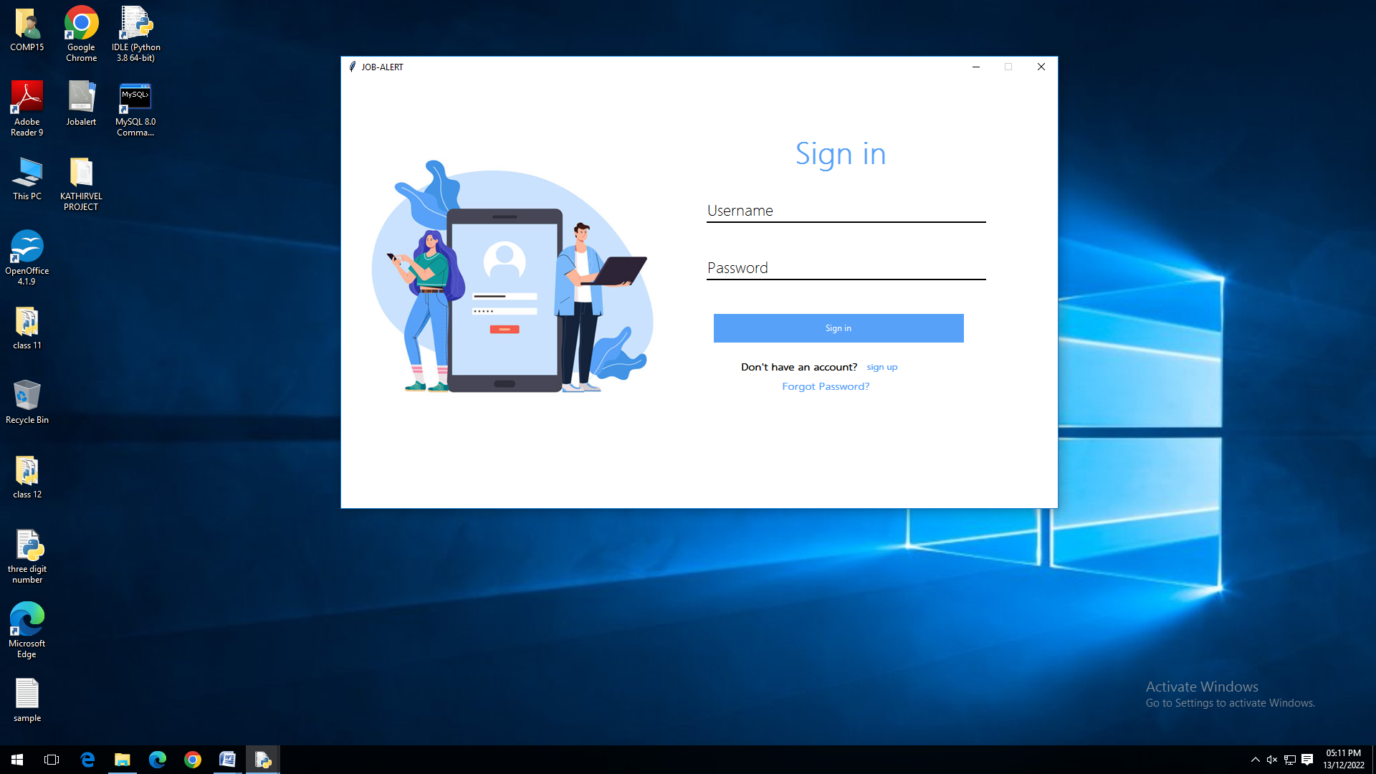
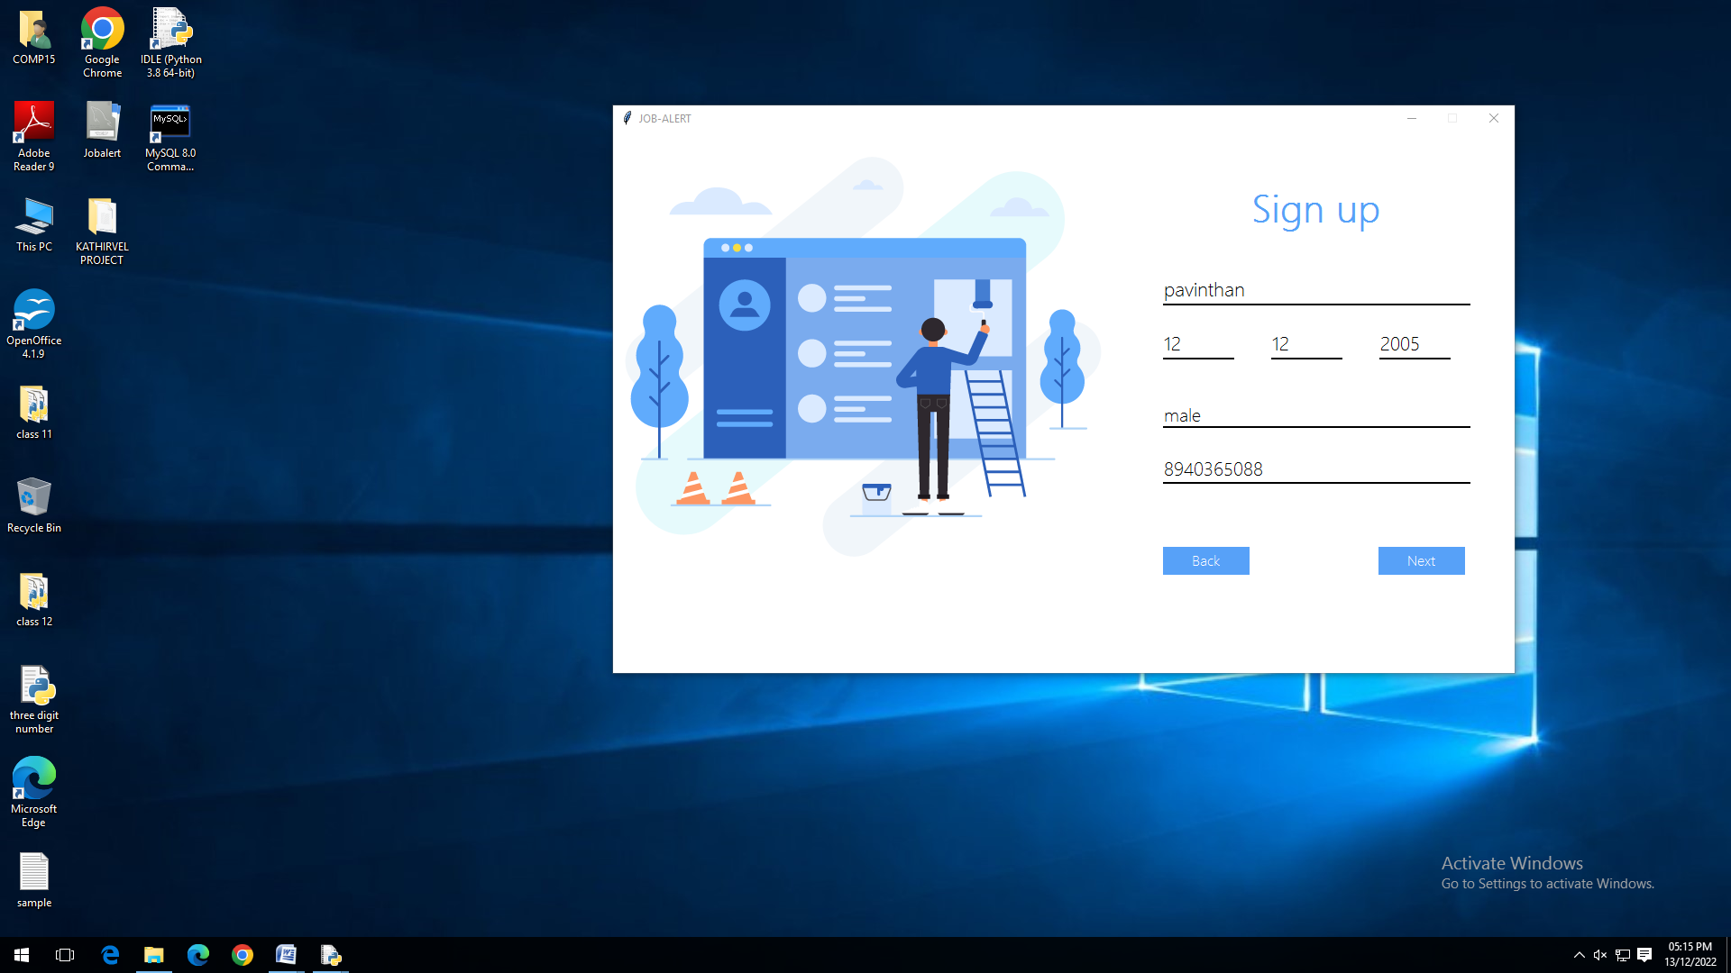
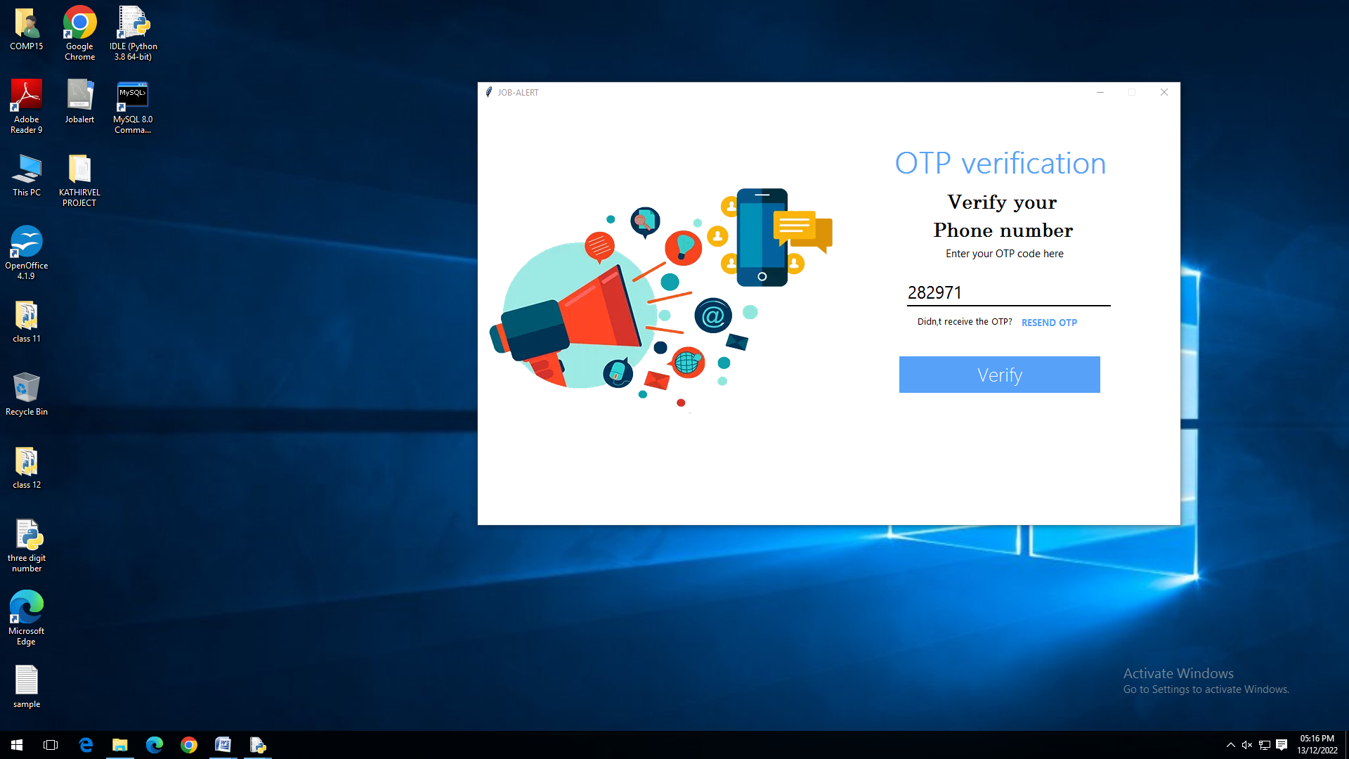

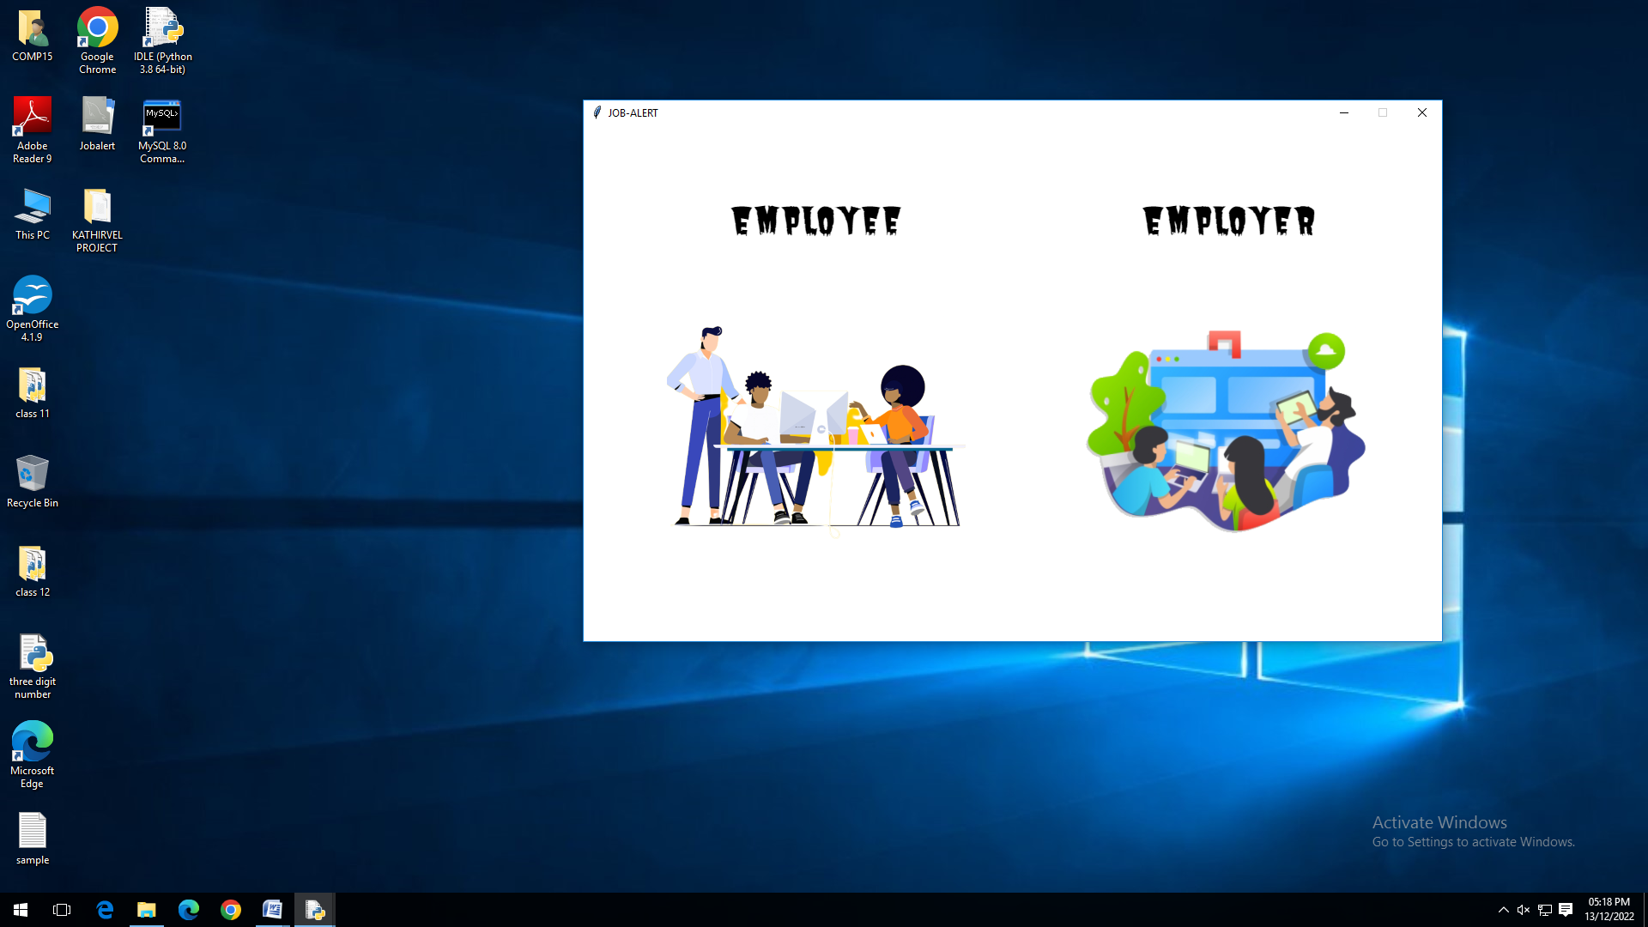
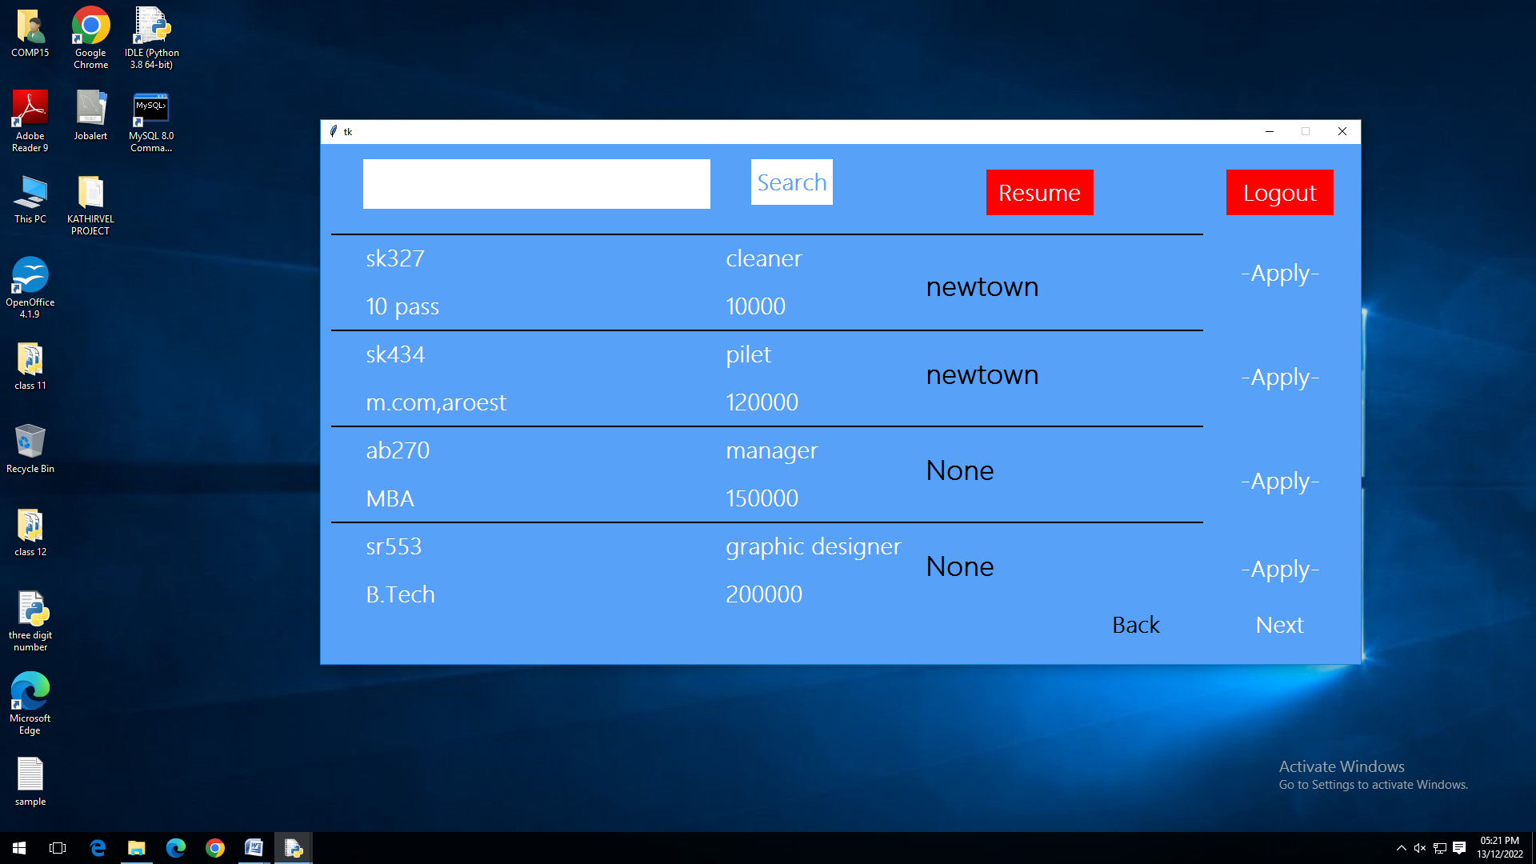
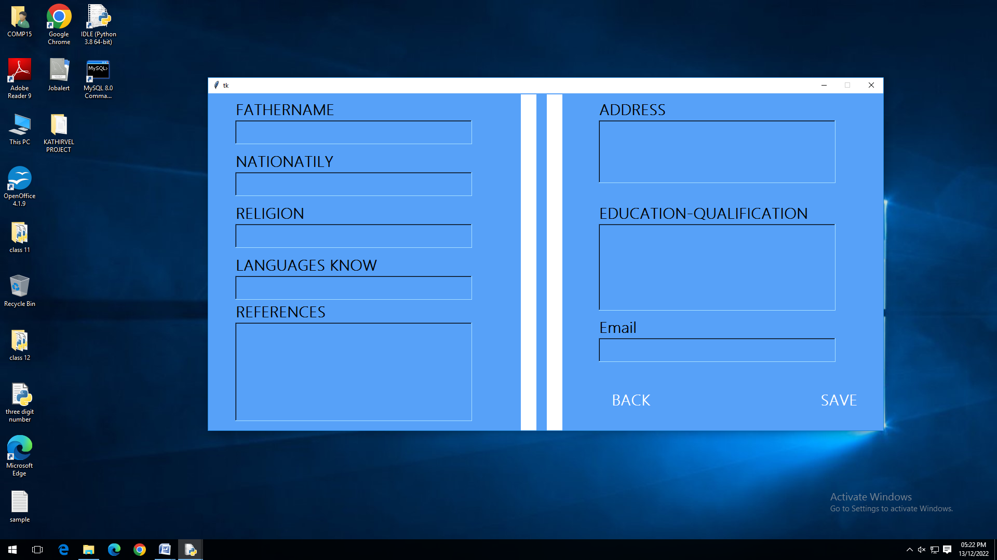
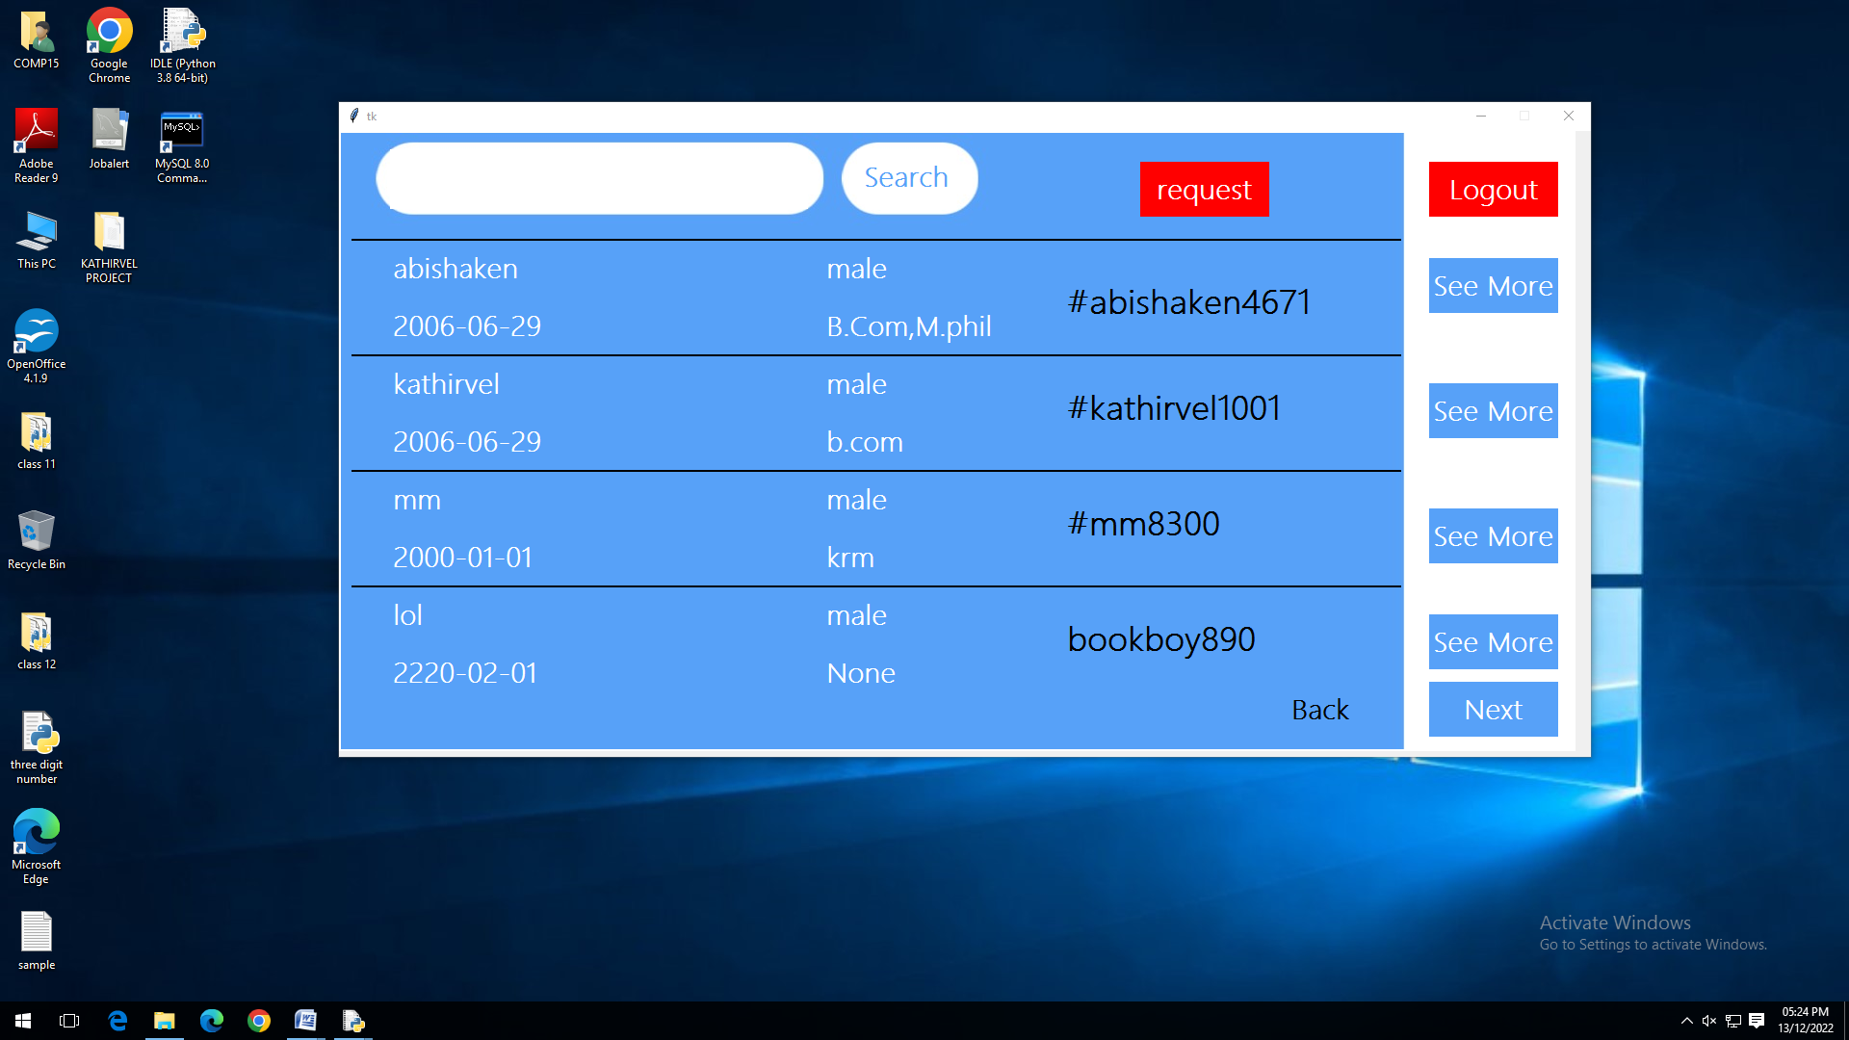

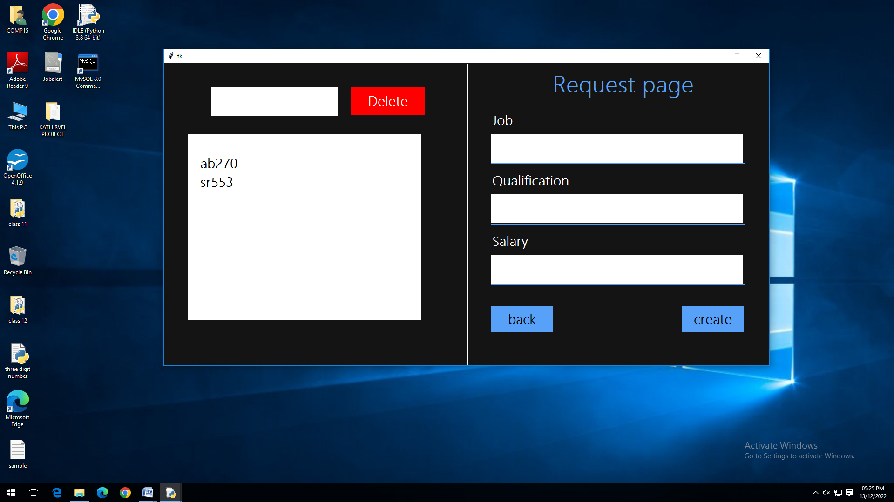

DATABASE SCREENSHOTS
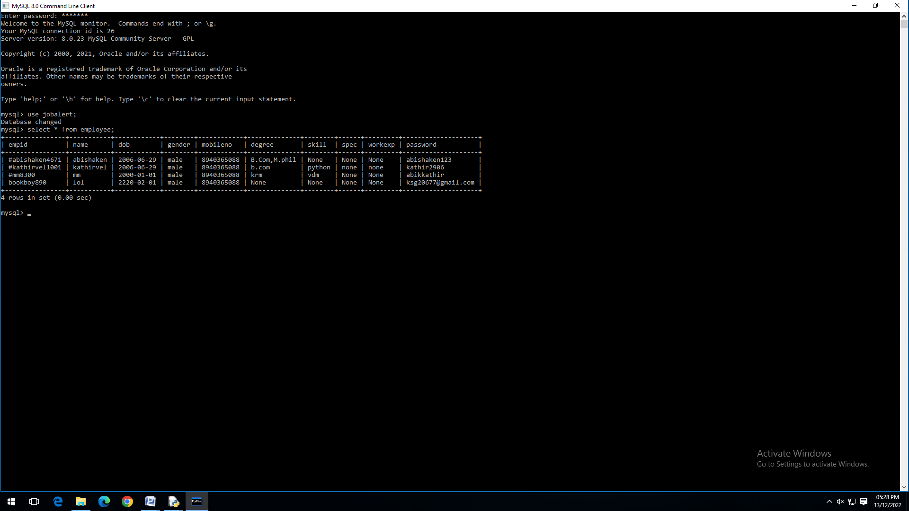

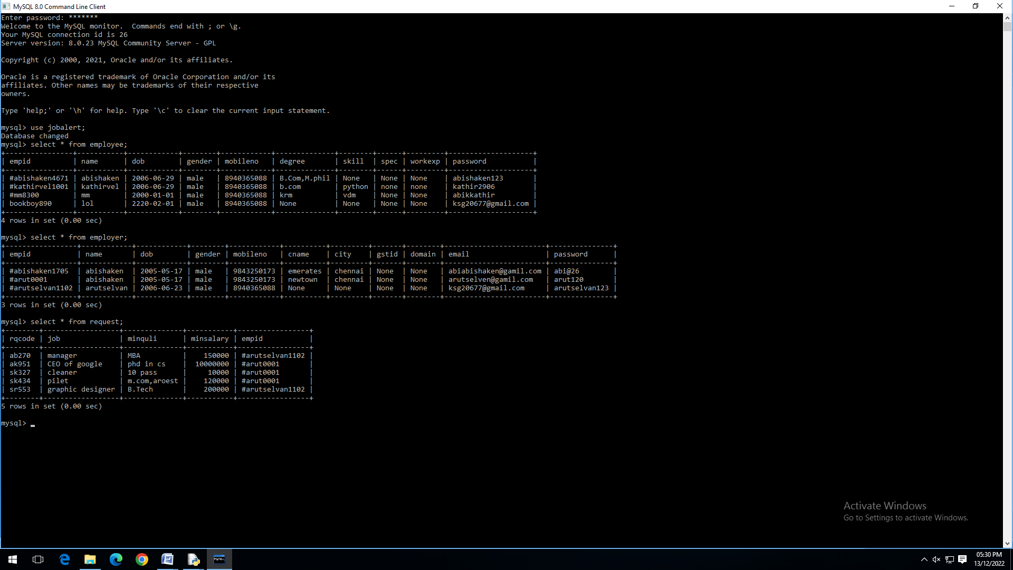
ADVANTAGES OF PROJECT

The main motive of this project is to help job seekers to find their respective job.

The project will be very useful for the freshers to approach a correct place to do their job.

For employers this project will be helpful in finding skillful employee and developing in the respective job feilds.

FURTHER DEVELOPMENT AREA
- This project can be further developed by:
- Adding more options to benefit job seekers as well as employers.
- Turning the program into web software or an application would be a great user interface.

BIBLIOGRAPHY
- https://github.com/python
- NCERT class 12 Computer science book
- Computer science with python SUMITA ARORA Text book

- https://docs.python.org/3/library/smtplib.html
For sending emails
- https://www.twilio.com/ for Generating OTP
- https://www.geeksforgeeks.org/python-gui-tkinter/ for using Tkinter

